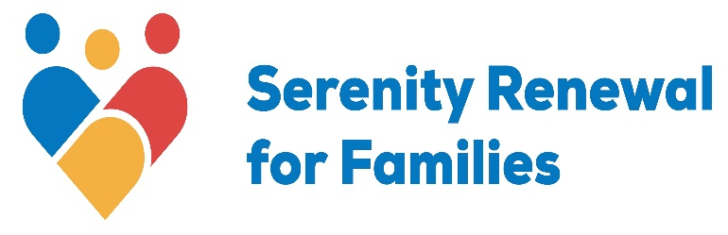
Phone: (613) 523-5143; 404 McArthur Ave., Ottawa, ON, K1K 1G8; Charitable # 11914-5787-RR0001

Workshop Facilitator: Part-time Contract Position
Organization: Serenity Renewal for Families (SRF)
Date Posted: January 26, 2024
Serenity Renewal for Families is a heart centered, non-profit agency which provides help and support for individuals and family members impacted directly or indirectly by addictions. We do this through family programs, short term counselling, educational workshops, and groups.
We are currently seeking qualified Workshop Facilitators to provide educational workshops to groups using in-person, virtual, and hybrid formats. Workshop topics include but are not limited to: Introduction to Healing and Recovery; Codependency; Family of Origin; Grief and Loss; Couples’ Communication; Anger and Resentment (in person only); Intimacy and Relationships for Men; Intimacy and Relationships for Women; Mindfulness for Mood; Loneliness and Connecting with Others; Healthy Boundaries; Body Image; Control and Perfectionism; and Forgiveness and Spirituality.
Experience working with parents and children/teens would be an asset. If you have a college diploma or university degree in a field related to addiction (see below), experience in addictions and codependency, experience with workshop facilitation, a passion for the recovery community, and want the flexibility to choose your own hours, we would love to meet you.
About SRF
Serenity Renewal for Families (SRF) has a 40-year track record of delivering a continuum of integrated individual and group supports to those affected by addictions. SRF believes that there are many paths to recovery. Our mission is to assist those affected by addiction to reclaim their lives and break the inter-generational cycle of addiction. No one is turned away for financial reasons.
Our culture is inclusive and collaborative. The emotional well-being of our clients, staff, counsellors, volunteers, and Board members is our top priority. We are flexible and responsive, and provide a personal touch that makes us unique. We want our team to feel valued, appreciated, and free to be who they are at work. We welcome diversity and strive to nurture a culture of equity and inclusion. All are welcome, regardless of race, religion, ethnicity, Indigeneity, disability, age, gender identity, sexuality, sexual orientation, class, or socio-economic status and anything else that makes them unique.

Job Type: Part-Time
Hours: flexible

Qualifications
The preferred candidate is a Psychotherapist, a Social Worker or Social Service Worker, an Addiction Counsellor, or holds a diploma or degree in a related field. Additional consideration will be given to candidates who are members of one of the following regulating bodies:
- College of Registered Psychotherapists of Ontario
- Ontario College of Social Workers and Social Services Workers
- Canadian Addiction Counsellors Certification Federation
They have a minimum of three years of experience in the provision of educational workshops, with specific experience working with clients affected by addictions and codependency issues. Knowledge and education specific to addictions and treatment approaches are required.

Language
English; Bilingualism an asset

Benefits of working at SRF
- The opportunity to be a part of a person-centered team
- Comprehensive orientation and training
- Excellent administrative staff support, including technical support for virtual and hybrid workshops
- Circle of Care in which staff consult with one another on shared cases to provide the best service possible
- Fully developed workshop packages are provided, including presentation materials and written content guides.
- Opportunities to develop new workshop materials if desired, in keeping with our overall mission and with approval of the Manager of Client Services and Director of Counselling
- Access to meeting rooms, reception and scheduling services and general office facilities.
- Flexible hours

Conditions of Employment
- All Workshop Facilitator positions within SRF are subject to background and criminal record checks.

If this is of interest to you, please send your resume and cover letter to Michelle Tasker, Manager of Client Services, Serenity Renewal for Families, at mtakser@serenityrenewal.ca and visit our website for more information about our organization at www.serenityrenewal.ca .

