TRANSFORMING DISABILITY KNOWLEDGE, RESEARCH AND ACTIVISM (TDKRA)
POLICY BRIEF
APRIL 2020
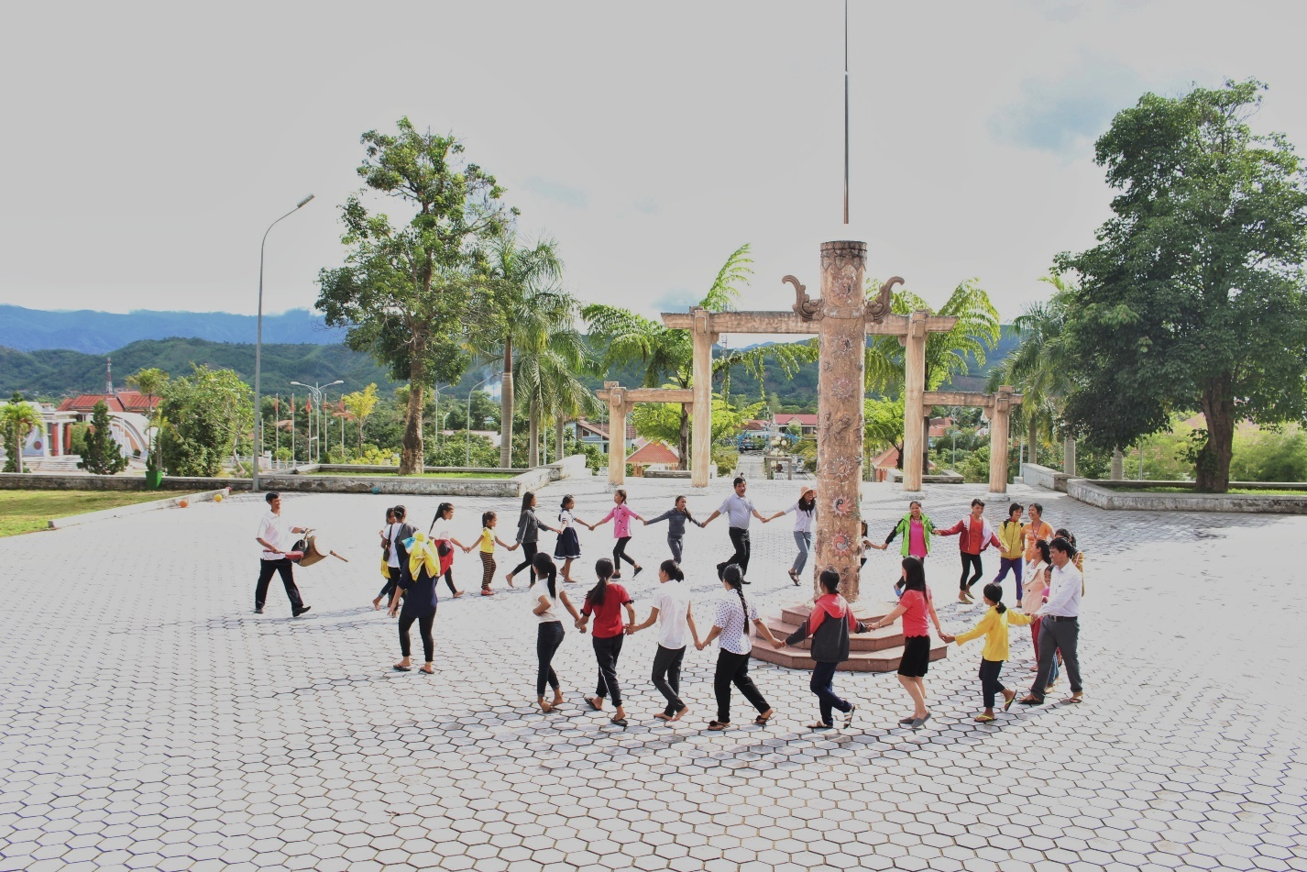

TDKRA 2016-2020 PROJECT SYNOPSIS
The project focuses on engaging women and girls with disabilities in three disadvantaged communities in Hanoi, Thua Thien Hue, and Can Tho of Vietnam in research to build local knowledge and develop activism in support of inclusion. It is funded by the Social Sciences and Humanities Research Council of Canada (SSHRC) from 2016-2020.

IN THIS BRIEFING. . .
- Research design and methodologies
- Project phases: main objectives, activities, and outcomes
- Knowledge mobilization & engagement
- Policy recommendations
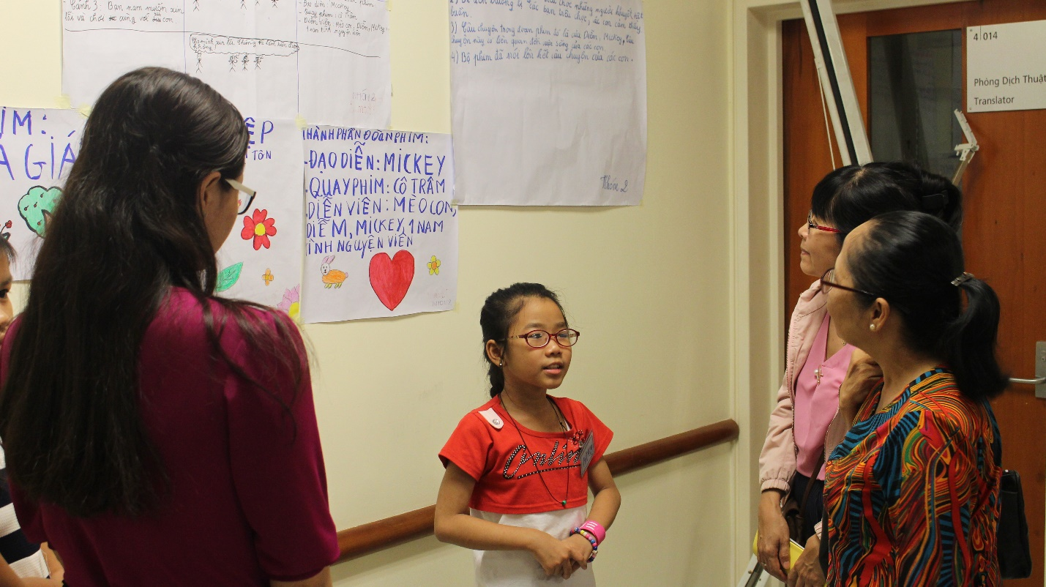

TDKRA 2016-2020
TRANSFORMING :Transforming traditional boundaries between research and activism.
DISABILITY: Recognizing unique contexts that shape meanings of disability in the global South.
KNOWLEDGE: Creating interdisciplinary, critical, reflexive, and decolonial knowledge practices which empower girls and women with disabilities to tell their stories of inclusion and exclusion.
RESEARCH: Participatory researching paradigm to engage and foster relationships with women and girls with disabilities, DPOs, and researchers in Vietnam and Canada.
ACTIVISM: Building inclusive and communityengaged practices that transform disability knowledge and actions.

Our Journey
Youtube: https://youtu.be/nIflV0zuL8k
Website: https://carleton.ca/tkaa/
Facebook: https://www.facebook.com/tdkravietnam

RESEARCH DESIGN & METHODOLOGIES
TDKRA is a participatory research project with a paradigm that is grounded in the values of the community (Nguyen, Stienstra, Gonick, Do, & Huynh, 2019). It aims to contribute something of value to the community in which the research is conducted (Kirby, Greaves, & Raid, 2006). This research paradigm is particularly useful for disability research in the global South, as it enables a mutually beneficial dialogue between researchers and participants in ways that value the participants’ voices and perspectives (Nguyen et al., 2019).
Between 2016 and 2019, the research team worked with three local communities and Disabled People's Organizations (DPOs). We developed partnerships, collected data, and organized 5 community engagement events and one national workshop which engaged with inclusion from the perspectives of women and girls with disabilities. We used participatory visual methods, including drawing, cellphilming, photovoice, community asset mapping, film productions.

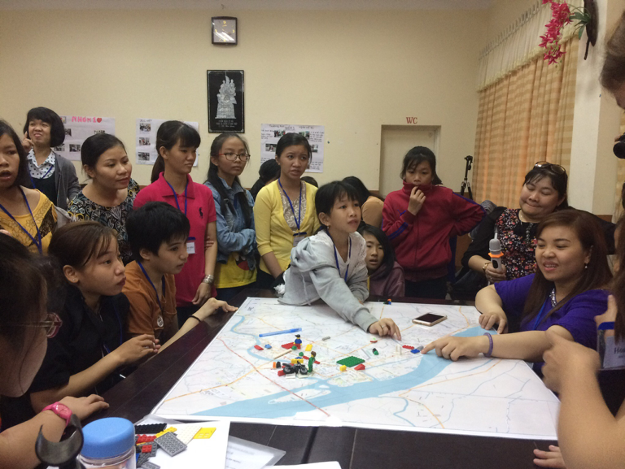

Effort has been made to foster relationships among women and girls with disabilities by inviting participants to reflect on how best to support their relationships and networking within the scope of the TDKRA project and beyond.
This was achieved through developing mentoring relationships as well as action plans for next stages.
TDKRA team also engaged with Disabled People's Organizations (DPOs) to build their capacity in conducting disability research and activism by strengthening their leadership and support networks that engage women and girls with disabilities in research activities.

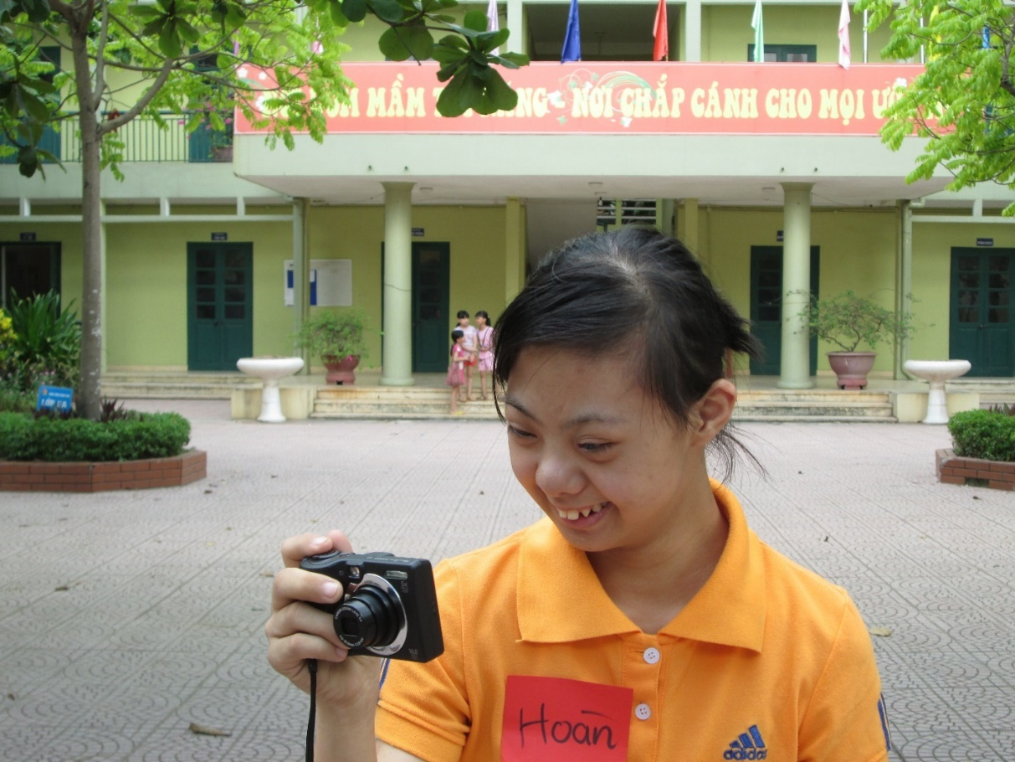
"I love my disability. I love my disabled peers. And above all, let's celebrate disabilities.
Be happy."

Phase I. 2016-2017
Objectives:
- To consult communities about their needs and interest in implementing the TDKRA project.
- To disseminate the project’s information to the local communities and girls and women with disabilities.
- To gain access to prospective participants.
Activities: Information sessions were held in different communities, which served as this project's preliminary fieldwork. The research team learned about a number of key concerns and needs pertaining to women and girls with disabilities.
Outcomes:
- Establishing trustful relationships with the local communities.
- Building a local network with DPOs in three communities.
- Getting access to women and girls with disabilities through information sessions and family visits.
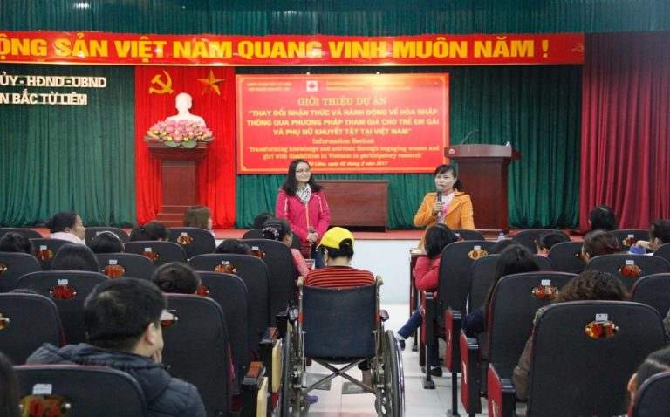
"EQUALITY REQUIRES WORDS WITH ACTIONS!"

Phase II. 2017-2018
Objectives:
- To develop relationships with local communities and team building.
- To engage women and girls with disabilities in training and sharing their stories.
- To connect the women and girls with disabilities.
Activities:
- Engaging in a range of activities based on participatory methods such as focus groups, cellphilming, drawing and media analysis.
- Training women with disabilities to become facilitators.
- Collecting data through workshops with small groups of women and girls with disabilities in each community.
- Engaging communities through photo exhibitions and public screening of cellphilms.
Outcomes:
- Women and girls with disabilities were able to tell their stories on inclusion and exclusion through participatory visual methods.
- While some women were able to challenge the ways disability is portrayed in the media, the girls found it difficult to challenge media stories.
- The use of cellphilming enabled the girls to challenge exclusion through their own ways of seeing, in so doing reframing the media narratives.
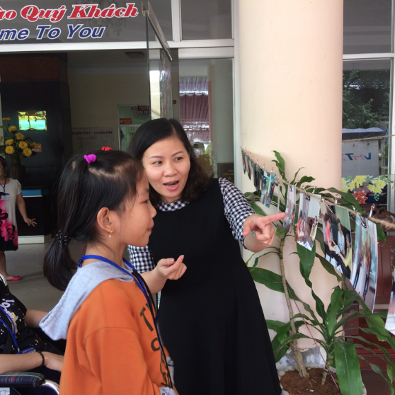
"I WANT PEOPLE NOT TO POINT AT ME."

Phase III: 2018-2019
Objectives
- To engage participants in reflexive practices on their participation through participatory analysis and filmmaking.
- To foster the participants’ public engagement by strengthening their networks and strategies for collective activism.
- To strengthen DPOs’ capacity and leaderships in relation to disability research and activism.
Activities
- Women and girls with disabilities engage in participatory film-making and decide the stories they want to tell.
- Women and girls with disabilities create storyboarding scripts and message for the film.
- Participation in community assets mapping and identifying the spaces of inclusion/exclusion in their communities.
- Film editing based on the consensus reached by participants for the overall message of film.
- Women and girls with disabilities decide on next steps and mobilizing their participatory productions.
Outcomes
- Fostering some meaningful engagement among the girls, women, their DPOs, and research team in the global North and South (Nguyen, 2016; Stienstra & Nguyen, in press).
- Fostering self-transformation through reflective practices which enabled the participants to reflect upon their own stories on inclusion and exclusion.
- Enabling the participants to envision their own ways of seeing and re-imagine their own stories through cellphilming and photo voice projects.
- The local DPOs successfully organized the workshops through their disability networks. Despite the lack of local resources, they felt stronger and more capable in engaging in the research activities.

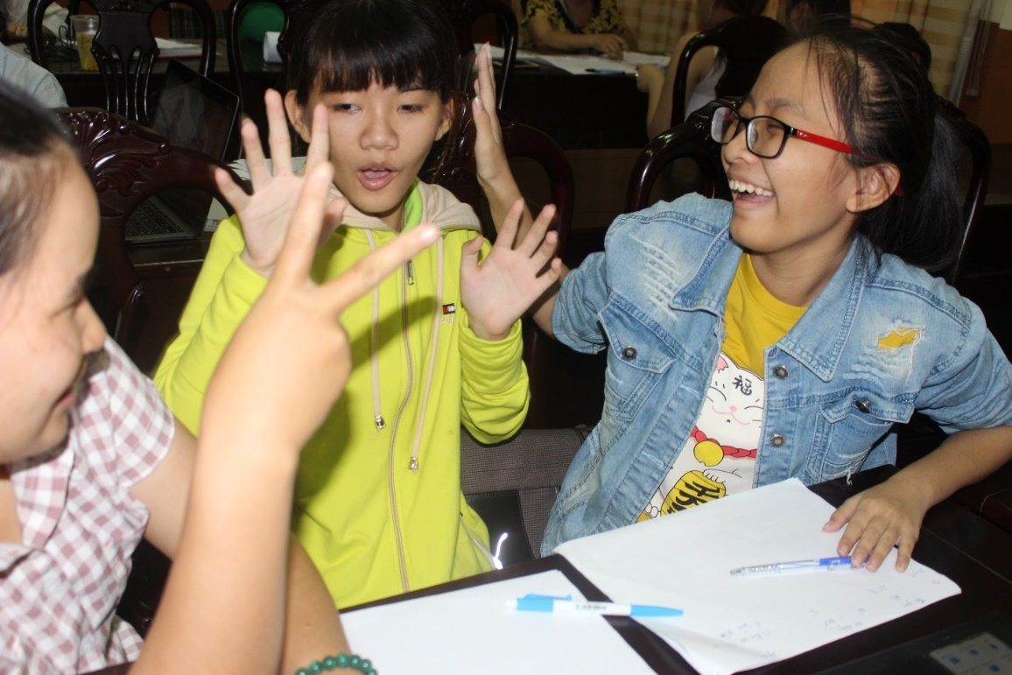
"THEY LOOK AT ME AS A STRANGER FROM ANOTHER PLANET."

Phase IV. 2019-2020
Objectives:
- To engage women and girls with disabilities in the three pilot sites in mobilizing their knowledge on their right to inclusion.
- To engage local communities and policy makers in the global South in building inclusive communities by working with girls and women with disabilities.
- To mobilize the DPOs leadership and advocacy. To engage universities, disability activists, graduate & undergraduate students in the global North in learning from and with women and girls with disabilities in the global South.
Activities:
- Knowledge mobilization through screening of the film Our Journey.
- Key stakeholders in all participating communities were engaged through the leadership of women and girls with disabilities in offering what are the next stages and hope for the project.
- Creating action plan through social media outreach.
- The participants drew self-portraits and wrote a response for the statement “I Am a Leader Because…”
Outcomes:
- "I am a leader because..." activity was a highly successful initiative engaging the women and girls with disabilities in articulating their skills, challenging internalized ableism and finding their voice.
- Transnational screening of the film Our Journey, in community engagement activities in Vietnam, Ottawa, and Montreal, Canada.

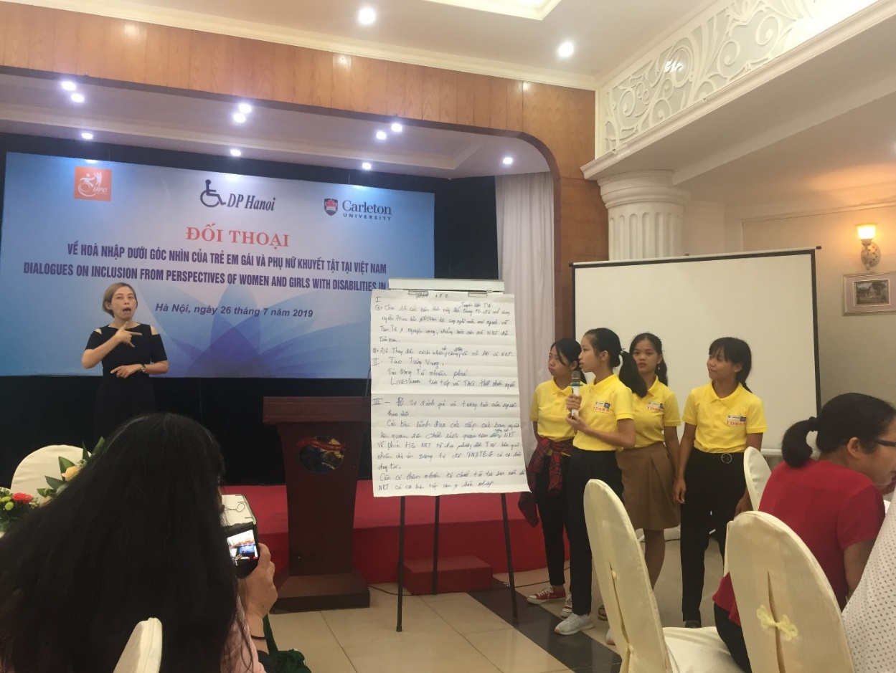
"There are many different colors that make a beautiful garden. I want to be a leader because I want my difference to be a new and unique color which prettifies the garden."

"I Am A Leader Because..."
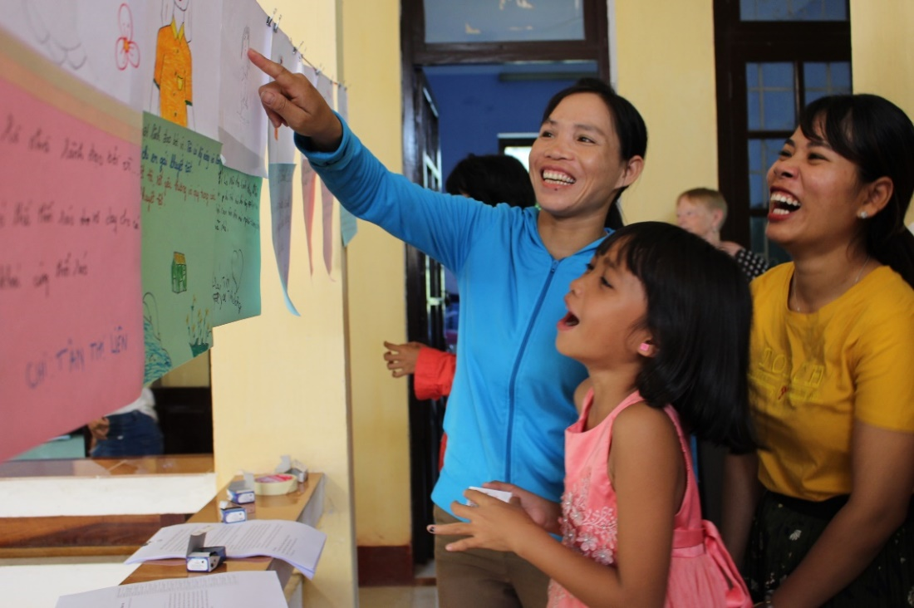
In the spirit of mobilizing knowledge and activism, in July 2019, the women and girls with disabilities took part in an activity to build their message and leadership through "I Am A Leader Because..." portrait activity. Through the creation of writings and drawings, the girls and women engaged in painting a picture of their strengths and skills. These drawings were then presented in an exhibition. This activity was part of the bigger knowledge mobilization initiative with the TDKRA research team.
The engagement of researchers and practitioners in the global South and North, along with women and girls with disabilities in Vietnam, opens up difficult conversations about implicit assumptions and practices that guide research and shape how and whose knowledge is reflected in the work.
Such engagement and research activity is particularly useful for disability research in the global South, as it enables a mutually beneficial dialogue between researchers and participants in ways that value the participants' voices and perspectives. Through engaging within their community and production of visual presentation, the disability community engages both their community and researchers.

ENVISIONING INCLUSION: TRANSFORMING DISABILITY KNOWLEDGE, RESEARCH AND ACTIVISM
Through the exercise of reflection on the film "Our Journey" and the catalogue Envisioning Inclusion: Transforming Disability Knowledge, Research and Activism to discuss tools to mobilize knowledge, the girls and women with disabilities outlined their expectations from community engagement.
Knowledge mobilization based on what the girls and women shared through the journey of engaging with the TDKRA project over the past four years, has produced transformation of knowledge, self and communities regarding disability.

OUR JOURNEY: DOCUMENTARY FILM
In March 2019, a one-day workshop took place with the aim to involve the participants in the film-editing process by discussing the content of the film and how they would like to mobilize the film. This film is co-produced by the women and girls with disabilities with the research team. The film reflects diverse voices and perspectives of the participants and generated dialogue among the participants about their inclusion and exclusion, as well as strategies for activism.
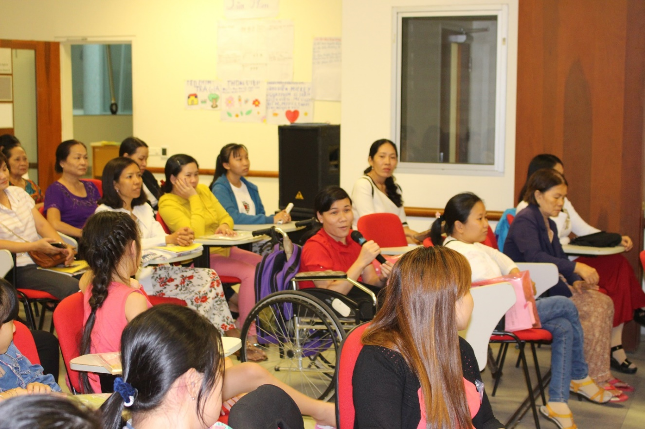
Following initial analysis and feedback from March workshops, in July 2019, a 3-day workshop took place with the overall objective of mobilizing knowledge produced by the women and girls with disabilities in the TDKRA project to their local and transnational communities.
Communities in Can Tho, A Luoi, and Bac Tu Liem engaged in discussions as to what approaches should be used to engage with their community members and policy makers through knowledge mobilizations: the journey to engage and enact change within their communities through research and engagement.

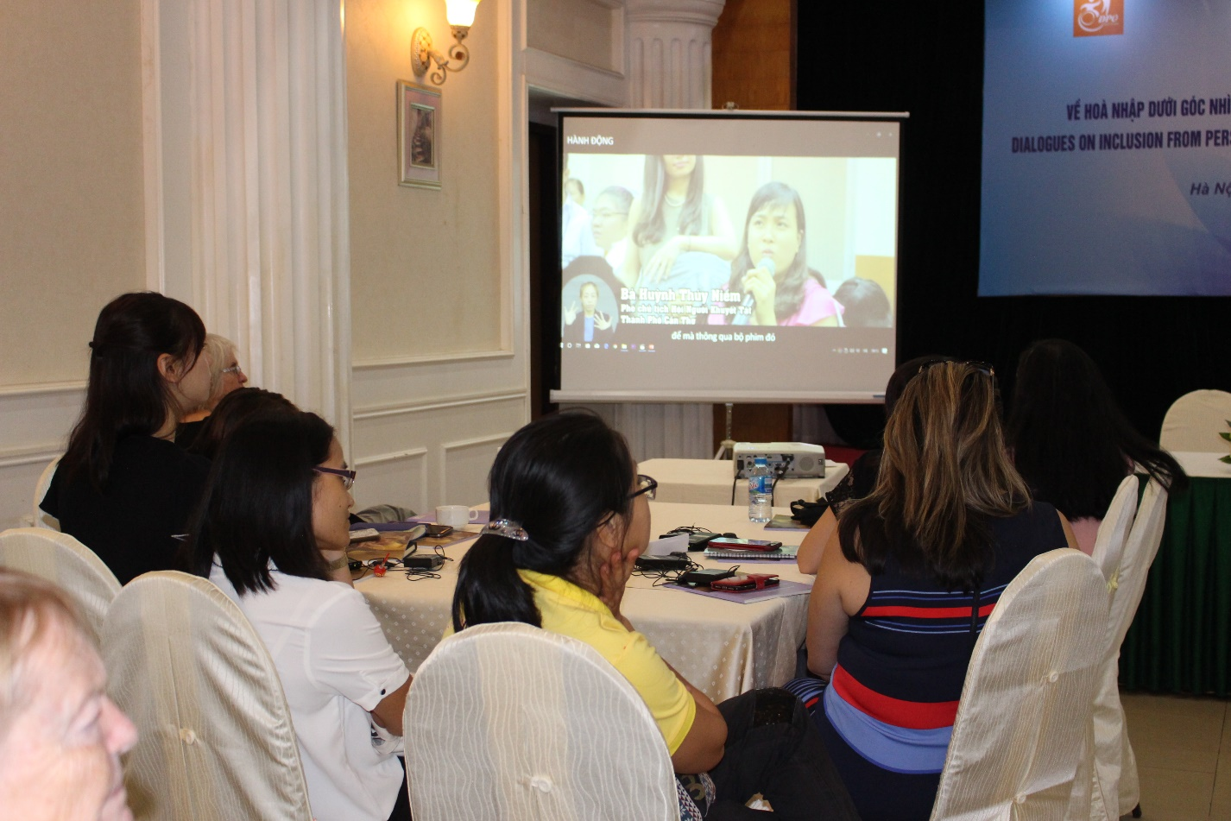
"It's not so easy to become a leader, but we have to go through a long path. Like me, before joining the project, I have not been able to speak out my opinion. But now, I can share with the team and everyone. Thanks to your training, today I can sit here and become a leader so I feel it's like a journey.”

POLICY RECOMMENDATIONS
- Creating multiple spaces for girls and women with disabilities to develop their knowledge, skills, networks, and to enhance their actions in relation to access and inclusion.
- Developing training and mentoring programs to build leaderships, advocacy skills, and to foster civic engagement with girls and women with disabilities.
- Using tools and products produced by girls and women with disabilities (e.g. films, drawings, photo voice, and other social media tools) to improve public awareness on their rights, capacities, and voices.
- Understanding the importance of local contexts when developing disability policies for women and girls with disabilities.
- Including girls and women with disabilities in public policy. Ensuring that women and girls with disabilities are consulted in relation to issues concerning them.
- Developing a substantive approach to disability inclusion to tackle systemic forms of discrimination against girls and women with disabilities in relation to their disability, gender, ethnicity, and socio-economic class.
- Developing a holistic approach to inclusive education to ensure that girls with disabilities can meaningfully participate in education and social institutions.
- Developing protective measures to tackle different forms of violence against girls with disabilities, including girls with intellectual disabilities, in schools and domestic contexts.
- Developing sustainable partnerships with DPOs and their communities to enhance their leadership on disability-related matters.
- Developing meaningful collaboration among research institutions, DPOs, civil society organizations, the United Nations agencies, and the government's policymakers in support of women and girls with disabilities in Vietnam and the global South.

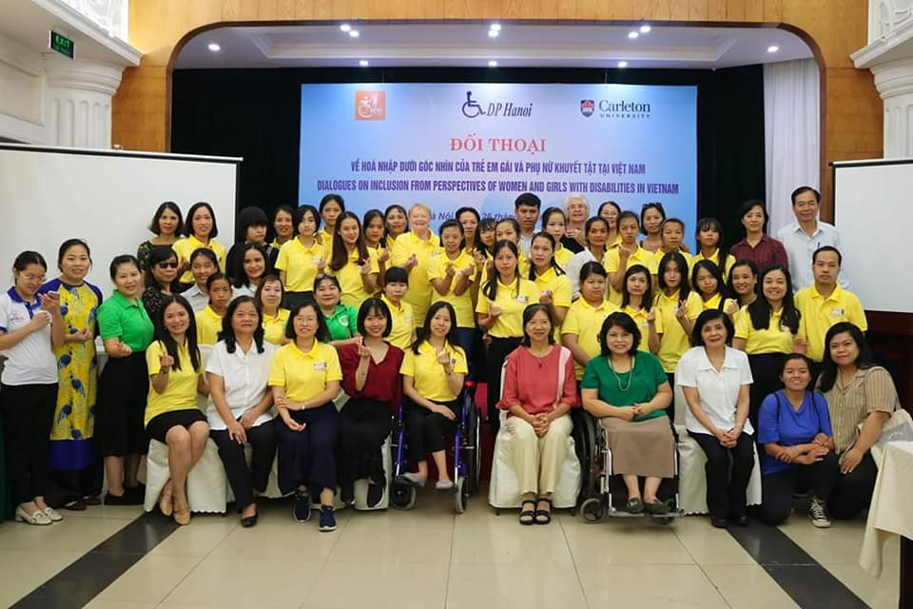
Experience Together! Transform Together! Act Together!

TDKRA RESEARCH TEAM & PARTNERS
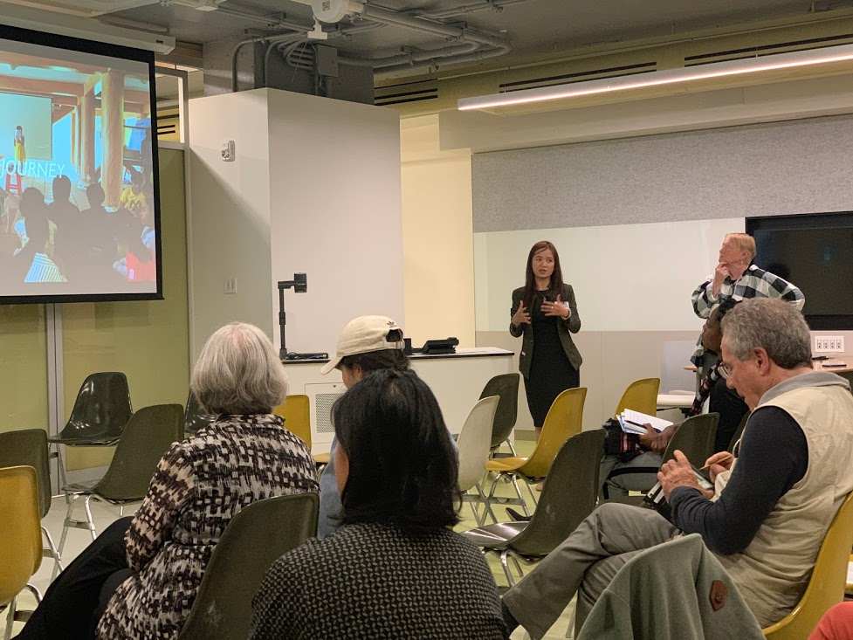
Xuan Thuy Nguyen
Principal Investigator
Carleton University

Deborah Stienstra
Co-Investigator
University of Guelph

Claudia Mitchell
Co-Investigator
McGill University

Marnina Gonick
Co-Investigator
Mount St. Vincent University

Collaborators
Nhung Huynh
Marcia Rioux
Huyen Thi Do
Lan Anh Nguyen
Naydene de Lange

Community Partners
Bac Tu Liem Association of People with Disabilities
Can Tho Association of People with Disabilities
Thua Thien Hue Association of Blind People
A Luoi Association of Blind People
Action to the Community Development Center (ACDC)

Research Assistants
Linh Dang
Tuyen Bui
Nadeea Rahim
Hikmet Mawi
Tammy Bernasky
Huong Dao
Emily Hill-Smith
Thao Le
Thuan Hong Do
Alexia Miron

