General comments:
- There are many varieties of a plant and each variety may differ the height it reaches, color. For e.g. different varieties of black-eyed Susan mature to different heights.
- Some plants grown from seeds may not produce flowers in the first year and will typically bloom in the summer of the second year.
- Like for most flowers and herbs, do not over fertilizer since too much nitrogen will create an abundance of foliage, and few flowers.
- Most perennials will spread horizontally unless you divide them every 3-4 years.
- You can always use a seed starting kit but it is not necessary.

Ligularia Denata (Leopard Plant)
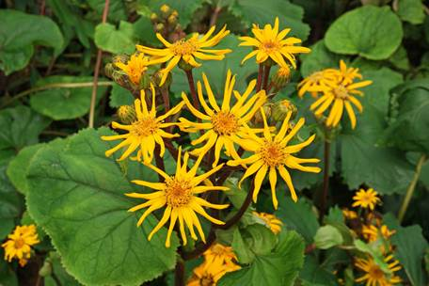
Flower/foliage details: Taller stems appear in June, bearing clusters of bright golden orange daisy flowers. Plants form a clump of large foliage of rounded, bronze-tinted leaves adorned with deep purple undersides.
How and when to grow plants from seeds:
Indoor: Ligularia seeds are erratic in germination and can take 14-42 days to sprout when kept at 13-18 C. Sow the seeds on the surface of moistened seed starting mix and barely press them in with your hand. Cover the pots or trays with plastic wrap to help hold in the moisture and keep the trays in a cool room.
Outdoor: Before the last frost or early in fall plant them 24-36 in (60-90 cm) apart.
Planting/Spacing: Plants can be spaced at 18 to 24 inches apart. Prior to planting mix in organic matter, a handful of bone meal and some peat moss to increase moisture retention.
Container gardening: If you have a large pot to support the plant height and width.
Height: 3-4 feet
Width: 2-4 feet
Soil/water/growing conditions/care/fertilizer: They thrive in areas along rivers or ponds so they are best to grow in a moist spot. They require consistently moist, nutrient-rich soil with plenty of compost or leaf litter worked into it though they can withstand boggy soil. Regular water them during dry periods, put mulch in the spring and occasionally fertilize them in spring and summer, remove dead inflorescences, cut back to the ground in fall.
Sun or shade: Full sun will result in the sturdiest plants but they can tolerate part-shade.
Bloom period: Early to late summer.
Harvesting seeds: Gather seed from a healthy plant in late summer once the flowers dry out and turn into dandelion-like seed heads. Plant the seeds fresh, or store them in a cool, dry place until late winter.
How to Propagate Ligularia: With a clean, sharp knife, cut the Ligularia root crown into the number of divisions you desire. Gently pull these division roots apart from the main roots and then immediately set the new division into the water and fertilizer mix. When you have all your desired Ligularia divisions, you can plant them. Clumps may be divided in the spring, every 3 to 4 years to maintain vigour.
Attracts/Repels: Attractive to bees, butterflies and birds

Hibiscus syriacus (Rose of Sharon) – seeds 2 colours
Light purple with burgundy center
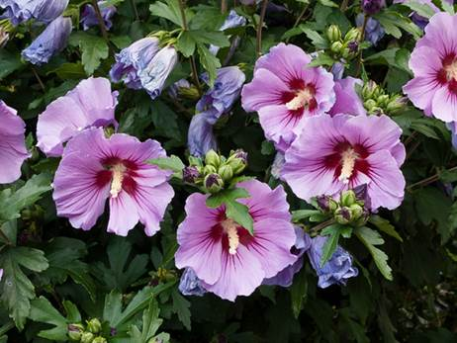
White with burgundy center (limited supply)

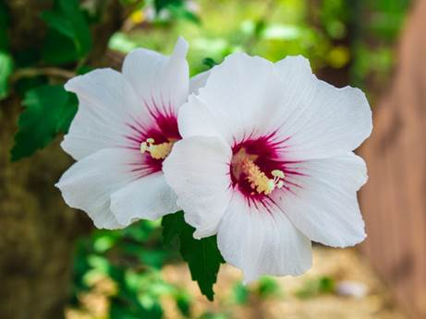
Flower/foliage details: An exotic beauty, Hibiscus syriacus (Rose of Sharon) is a vigorous, vase-shaped, deciduous shrub with large, showy flowers resembling hollyhock blossoms.
How and when to grow plants from seeds:
Indoor: Sow seed indoors 6-12 weeks before the last frost depending on your zone. Seeds soaked overnight help jumpstart the process. Use a sterile potting mix for germination. After sowing, keep the seeds warm by placing them in a sunny window. Expect seedlings to sprout in 2-4 weeks. Sow the seed 1/2 inch deep into well-draining soil and keep at 60% humidity in full sun or under lamps. After 4-5 weeks, transplant into larger pots, taking care not to disrupt the taproot.
Outdoor: Plant the seeds outside in spring after danger of frost has passed – plant them around 0.6 – 1.2 cm (1/4 – 1/2 inch) deep in an area that gets full sun, and seedlings should emerge later in the spring.
Planting/Spacing: 6-10 ft apart. Dig a hole as deep as the root ball and 2 times wider. Remove the plant gently from the nursery pot, loosen the soil around the roots, set the plant into the hole with the top of the root ball at soil level or slightly above, back fill the hole with soil and tamp down slightly to remove air pockets and water well. You can mulch with a layer of shredded bark to retain moisture.
Container gardening: No
Height: 8-12 feet
Width: 6-10 feet
Soil/water/growing conditions/care/fertilizer: As the last frost approaches in the spring, expose the plant slowly by gradually exposing them to outdoor conditions during the day to achieve a stronger and more weather-resistant plant. Rose of Sharon prefers moist, well-drained soil and area with good drainage. Once the plant is established, it is drought tolerant. Better branching and thus more flowers can be achieved by pinching back the tips when the young plant is around 6-8 inches in height. Rose of Sharon aren’t fussy about soil type or pH; any well-drained soil will do. Water deeply but less frequently to encourage deep, healthy roots. Fertilize in early spring by applying a granular rose fertilizer according to the label. Reapply each spring. Rose of Sharon needs little to no regular pruning. If you wish to prune, however, late winter or early spring is the best time to do so. Up to one-third of the plant can be removed at a time. Rose of Sharon seeds usually fall close to the mother plant, it is possible that you will see little seedlings sprout on their own next spring. Look under the mother plant – you could simply transplant these seedlings to preferred locations in your garden. At the same time, consider pulling out any seedlings you don’t want, (because they can multiply and overrun your garden) but if you do want them, transplant them to where you want them to grow.
Sun or shade: Full sun to partial shade, six or more hours of direct daily sun promotes maximum blooms.
Bloom period: Midsummer to fall
Harvesting seeds: By the end of October the flowers on the plant should have developed into green seed pods. These will ripen after few weeks, turn brown and dry out, getting ready to burst and release the seeds. In order to germinate next spring, the seeds must have ripened and also need to be exposed to cold temperatures for a period (hence they ripen in winter!). You can either pick the seedpods when they have turned light brown and store them in a cool dark place until they open to release the seeds and store in an envelope in a cool, dry location or, if you want to keep them for a longer period, make sure moisture does not lead to mold and spoil the seeds.
How to Propagate Rose of Sharon: Rose of Sharon can be easily rooted in June and July. Simply take several cuttings from the new growth about four inches long and remove all but the top two or three leaves. Then dip the bottoms of the cuttings into rooting hormone (available at most garden centers.) Fill a pot with some premoistened soil-less mix. Alternatively, propagate your Rose of Sharon cuttings in water. Some gardeners like to start the cutting off in just a clear glass or plastic container of water rather than planted in compost. What's good about this is you can see the roots form.
Attracts/Repels: Hummingbirds, butterflies are attracted.

Echinacea (Cone flower) – 2 colors (Mixed and Purple) Limited Colors

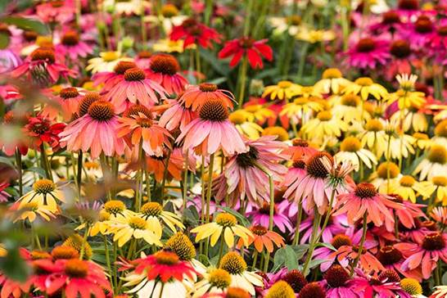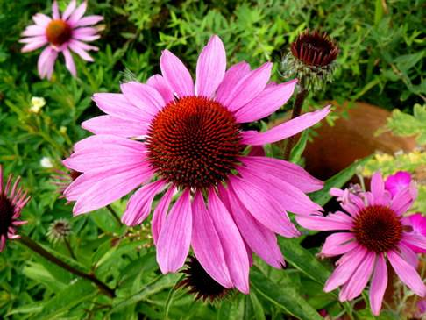

Flower/foliage details: Gently drooping petals and prominent cones, foliage is firm and rough, as are the stems and the center of the flowers. Entire plant, except for the colorful petals, is surprisingly stiff. The leaves and stems are usually covered in fine, stiff hairs, as well.
How and when to grow plants from seeds:
Indoor: Sow echinacea seeds indoors 8-10 weeks before outdoor planting date in spring. Cover the seeds lightly with 1/4 inch of seed starting mix. Keep the soil moist at 18-21 C. Seedlings emerge in 10-20 days. Flowers reliably bloom the first year from seed if sown early. Sow seeds shallowly at only 3mm (1/8 inch) deep. If starting indoors, provide total darkness and a soil temperature of 21-25°C . Once sprouts appear, provide bright light. Coneflowers started from seed may take 2 to 3 years before producing blooms. Too warm and the seeds won’t germinate. That means that a cool basement or garage might be your best bet.
Outdoor: requires a cold, moist period—called stratification—in order to germinate. Sow seeds thickly in the fall (after hard-frost in the north and before winter rains elsewhere), covering lightly to discourage birds from eating them. outdoors (when the soil temperature has reached at least 18°C)
Planting/Spacing: Space plants 30-38cm (11-15 inch) apart. If you’re planting seeds, sow them at a depth of 1/8 inch and expect a 15- to 30-day germination period. Loosen the soil in your garden using a garden fork or tiller to 12 to 15 inches deep, then mix in a 2- to 4-inch layer of compost.
Container gardening: Echinacea can be grown in a container or pot as long as it's deep enough to accommodate the plant's taproot. The pot should have plenty of drainage holes and some gravel or crushed rocks in the bottom to allow for drainage. If you are moving a potted plant into the ground, dig a hole about twice the pot’s diameter and carefully place the plant in the soil. Bury the plant to the top of the root ball, but make sure the root ball is level with the soil surface. Water it thoroughly.
Height: Up to 4 feet tall (depending on the variety)
Width: 12-36 inches
Soil/water/growing conditions/care/fertilizer: Echinacea likes average, well drained, slightly acidic soil but perform best in soil that’s rich so mix in organic matter. They tolerate poor rocky soil, but will not grow in wet, mucky soil or soil that drains poorly, or standing water on their roots. A moderate amount of water is ideal, but they are drought-tolerant once established and can take the heat! In late spring, provide supplementary water only if the season is extremely dry or your coneflowers are newly planted. Provide an inch of water a week, a light layer of compost, manure or light mulch when the flowers start to form in the spring or in the fall. You can cut back in fall unless you prefer to leave the seed heads. When flowers are faded/done blooming, deadhead if you wish to prolong the blooming season. But consider leaving late-season flowers on the plants to mature; the seed heads will attract birds and promote self-seeding. Deadheading will prevent self seeding if this is your preference. To deadhead, cut the dead flower back to a leaf where you can see a bud ready to swell. To encourage delayed blooming for fall enjoyment, cut coneflower plants back by 1 foot when plants come into bloom. This will result in later-flowering, more-compact growth because coneflowers can get leggy. Cut some and not others for more staggered bloom heights and times. You do not need to fertilizer; just ensure your soil has plenty of organic matter when you plant.
Sun or shade: Echinacea need at least four hours of sunlight per day and they will thrive in spots with morning shade and afternoon sun or vice versa.
Bloom period: Late spring to late summer
Harvesting seeds: Remove the seed heads from coneflower plants by snipping the stem just below each seed head with a pair of scissors. Drop the seed heads into a bucket, bowl or paper sack, and then spread the seeds in a single layer in a tray or shallow cardboard box such as a clean pizza box, don’t cut back coneflower plants and they’ll self-seed successfully and if do not want that, remove the seed heads.
How to Propagate Echinacea: You can start this flower from seed, nursery starts, stem cuttings, or by division. New plants can be propagated by dividing established clumps. To divide, take a spade and shove it down into the soil at the point where you want to separate the plant. Dig around the clump, carefully lift it, and shake or wash off the soil. You can also start echinacea cuttings in late fall when the plant is dormant. Water the parent plant to a depth of 3 inches the night before taking the cuttings to ensure the soil is soft and the roots are hydrated. If dividing or transplanting coneflowers, do so in the spring or fall. You can start this fantastic flower from seed, nursery starts, stem cuttings, or by division. Basal stem cuttings can be taken in the spring from new growth. As the plants mature over the summer, the stems hollow out and you can’t use them to take cuttings any longer. In the spring, cut a four- to six-inch-long piece of stem near the soil line. Dip it in powdered rooting hormone and place the cutting in a mix of a soilless potting medium in a six-inch pot. Keep the medium moist, adding more water when the top half-inch of the medium dries out. New roots should form in the next week or so, and new leaf growth should emerge shortly after that. Once you see that several new leaves have formed, you can put the plant out in the garden. Don’t be disappointed if some of your cuttings fail to root. It’s a good idea with this plant to start a few more than you think you’ll need.
Attracts/repels: Draw butterflies, bees, and birds to the garden, with prickly stems, they are more deer-resistant than most flowering plant. Favorite of the herbal medicine industry can be used as food and medicine.

Black Eyed Susan – double-flowered with large golden-yellow blooms
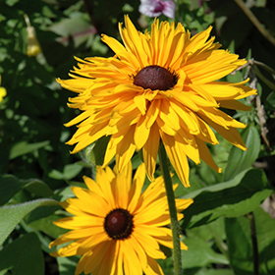
Flower/foliage details: Double flower heads are large and showy at the ends of long, thin, erect branches, florets orange to orange-yellow and spreading like spokes of a wheel. Flowers are 2 to 3 inches across and the leaves are thin and long, lanceolate-to-ovate in shape, prominently veined rough to touch and sparsely toothed. Leaves are several and grow irregularly along the length of the stalk.
How and when to grow plants from seeds:
Indoor: Sprinkle the seeds on top of regular seed starting mix about six weeks before the last frost date. Do not cover the seed as they need light to germinate. Plant your seedlings outdoors after any danger of frost has passed.
Outdoor: Seed may be sown directly in the garden when the soil temperature is roughly 21 C and will begin to germinate in 2 to 3 weeks. Plant when the soil temperature has reached 21 C for best seed germination, usually in May. Plant in moist, well drained and loosely covered soil.
Planting/Spacing: About 18” apart
Container Gardening: Container gardening black-eyed Susan isn't ideal. They produce deep roots and thrive in natural soil. However, a wide-mouthed, deep container can be configured with the right soil to give the flower a semblance of its natural environment, with plenty of organic matter and enough depth so the roots don't soak.
Height: Different varieties of black-eyed Susan mature to different heights. Some max out at 18 inches, while others can be up to 4 or even 6 feet tall. Seeds you have will grow 3-4 ft.
Width: Will spread if not divided.
Soil/water/growing conditions/care/fertilizer: It’s best if soil is fertile (not poor) though they can tolerate tough conditions. Be sure to remove faded/dead flowers to prolong blooming. Divide perennial types every 3 to 4 years to ensure healthy plants and to prevent excessive spreading. Cut off faded and wilted Black Eyed Susan blooms throughout the growing season to keep the plant tidy and in control. In autumn, cut Black Eyed Susan back to about 4” tall (10 cm.) or, if you wouldn't mind a few more Black Eyed Susan plants, let the last blooms go to seed for the birds.
Sun or shade: Prefer full sun but do well in part shade
Bloom period: June to September
Harvesting seeds: When the petals have fallen off you are left with a black cone. Cut the cones off and place them in a container that has a lid. Cover with the lid and give the container a 30-second hard shake. This will loosen the seeds from the cone.
How to Propagate Black Eyed Susan: Can be divided in early spring, just as growth begins to develop, or in the fall after they finish flowering. Simply dig up the root ball and cut it with a sharp knife, making sure each division has roots. Replant the divisions about 12 to 18 inches apart.
Attracts/repels: Excellent for attracting butterflies, bees, and other pollinating insects.

Note: Plants may not produce flowers in the first year. They typically bloom in the summer and fall of the second year.
Calendula
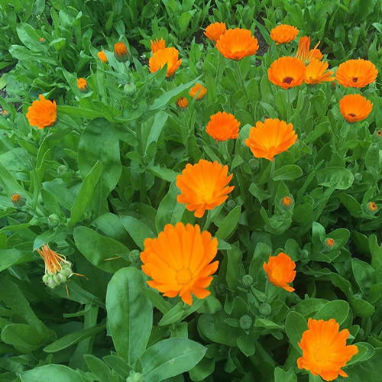

Flower/foliage details: The flowers bright orange, comprising a thick flowerhead 4–7 cm diameter surrounded by two rows of hairy bracts and the leaves are oblong-lanceolate, 5–17 cm (2–7 in) long, hairy on both sides, and with margins entire or occasionally waved or weakly toothed. Leaves and petals of this plant are edible. The leaves are typically bitter and often are added to leafy salads. The fresh petals are used as a garnish.
How and when to grow plants from seeds:
Indoor: Seeds can be started indoors in seed trays 3-4 weeks before frost-free date and transplanted into the garden.
Outdoor: Or direct sow in early autumn in Zones 8-10. Sow seeds 5mm (¼”) deep, and aim for a spacing of 15-45cm (6-18″) between plants.
Planting/Spacing: 15-45cm (6-18″) between plants
Container gardening: You can grow them in containers but ideally shorter varieties with the right nutrients, soil, moisture and lighting will do well in a container. Use well-draining, organic potting soil or make your own mixture with half garden soil and half well-rotted compost.
Height: Almost 2 feet tall
Width: Will self seed and spread and if you do not want that, remove as soon as the flowers have died and seedpods remain.
Soil/water/growing conditions/care/fertilizer: Calendula grows easily in any regular garden soil, and thrives in a pH range of 5.5-7.0. Calendula is tolerant of ordinary soil, yet prefers optimal conditions that offer rich, nutritious organic soil. Calendula are best planted in well-drained soil of loam, sand and chalk within a neutral, acidic or alkaline PH balance. Flowers tend to open with sunny, dry weather and close in cold or moist conditions. Pinch back young plants to encourage bushy growth. Occasional feeding is rewarded, but unnecessary. Keep plants watered, but try to avoid overhead watering as plants are susceptible to mildew. Like most flowers and herbs, however, go easy on the fertilizer since too much nitrogen will create an abundance of foliage, and few flowers. Flowers will rebloom constantly if old blooms are dead-headed. The plants may be weaker due to the hotter temperatures, but they will still give you extended flowering.
Sun or shade: They enjoy full sun — or even partial shade in hot summer regions. They are best positioned in an area of full sun or part shade.
Bloom period: May to early fall
Harvesting seeds: You should wait to collect calendula seeds until they are fully brown and dry. The seeds are hard and somewhat spiky. Store them in a dry place.
How to Propagate Calendula: Calendula can only be propagated through seeds.
Attracts/repels: Calendula repels asparagus beetle, nematodes, and tomato hornworm. It also attracts beneficial insects, so this edible flower. Leaves and petals of this plant are edible. The leaves are typically bitter and often are added to leafy salads. The fresh petals are used as a garnish.

Gaillardia (Blanket flower) – Arizona Sun

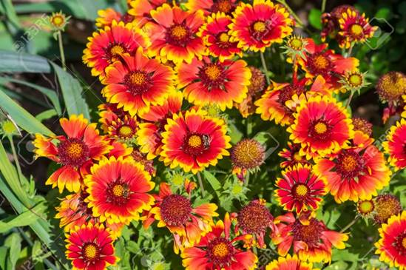
Flower/foliage details: Yellow-tipped bright-red blooms crown 2- to 3-foot stems of downy, muted-green leaves. The petals are a mango orange color and they appear to have ends that are dipped in peach paint.
How and when to grow plants from seeds:
Indoor: If starting indoors, provide bright light and a soil temperature of 21°C. Sow on the surface of the soil. They can also be sown indoors 4-6 weeks before last frost. These would be transplanted out once daytime temperatures are consistently above 10°C. Seeds will germinate in 7-20 days. Provide bright light and a soil temperature of 21°C
Outdoor: Direct sowing is easiest, and is done after last frost, fall is not a preferable time to plant in Ottawa considering the weather.
Planting/Spacing: Transplant or thin to stand a distance of around 16 to 20 inches (30 to 40 cm) between plants.
Container gardening: Yes gaillardia is fine for containers. Make sure you have excellent drainage and use a commercial potting mix. When planting blanket flower in a pot, it will be important to choose a container that is of adequate size. For the best bloom display, many gardeners prefer to place several plants into one larger pot. Container grown blanket flowers will require well-draining potting mix.
Height: 30-45 cm (12-18 inches)
Width: 1 ft
Soil/water/growing conditions/care/fertilizer: Pinch back young plants to encourage bushy growth. Occasional feeding is rewarded, but unnecessary. Keep plants watered, but try to avoid overhead watering as plants are susceptible to mildew. Like most flowers and herbs, however, go easy on the fertilizer since too much nitrogen will create an abundance of foliage, and few flowers. Flowers will rebloom constantly if old blooms are dead-headed. The plants may be weaker due to the hotter temperatures, but they will still give you extended flowering. Does need well-draining soil. It will grow in somewhat moist conditions, but heavy clay soil will probably kill it. Gaillardia will deal with all kinds of soil but it will bear most flowers in light, does not tolerate wet or heavy clay soils and likes well drained soil. Feed once, just as flowering begins, and top-dress with well-rotted manure once in summer. Deadhead regularly. Water regularly during dry spells, keeping leaves as dry as possible – this can be done in the early morning, so leaves dry off by noon. Gaillardia thrive in full sun, in average, medium, well-drained soil, in rocky or sandy places.
Sun or shade: Thrives in full sun but can handle some partial shade, particularly in hot climates, but they will get a bit floppy and will not flower as profusely as they generally prefers a dry, sunny site.
Bloom period: August to September.
Harvesting seeds: Each tiny seed is attached to a tuft of fine, fluffy down that makes them easy to harvest and handle. To harvest the seeds, snip off the seed heads after they dry out and turn off-white, pinch the seed head until it breaks apart and all the individual seeds come loose. Set the seeds in a cool dry location on a piece of paper to draw out any moisture from the seeds before storing them.
How to Propagate Gaillardia: To harvest the seeds just pinch the seed head until it breaks apart and all the individual seeds come loose. Set the seeds in a cool dry location on a paper to take out any moisture from the seeds before storing them.
Attracts/repels: Though this flower is not scented, it is much loved due to its attractive blooms by a diversity of bees including green metallic sweat bees, bumble bees, and others who are drawn to the brightly colored flowers and is used got food, rest and shelter.

New England Aster - Purple
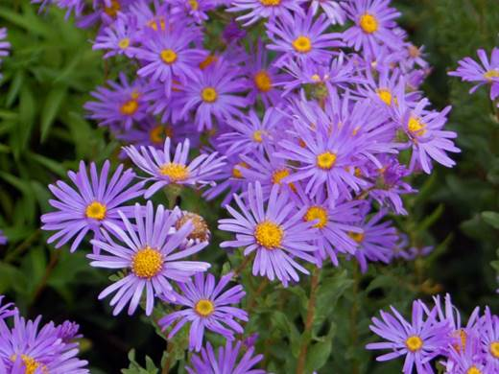

Flower/foliage details: Vivid violet blue blooms appears in the fall are more sparse, hairy leaves will clasp the thick stem. New England Aster are taller than New York Aster.
How and when to grow plants from seeds:
Indoor: Sow indoors 4-5 weeks before the last frost and cover them well with moist seed starting mix. Sprinkle one or two seeds in each seed starter pot or egg carton cell filled with potting medium. Barely cover them, so that they are no deeper than 1/8 inch. Place the containers in a location that receives indirect sunlight. Keep them evenly moist, but not soggy. Indoor aster seed care involves keeping the seeds at a temperature of 18-21 degrees C. and providing seedlings with ample light as soon as they emerge. Thin the seedlings out when they have one set of true leaves, keeping the stronger of the two in each cell. When the last average frost date has passed, acclimate the seedlings to the outdoors by setting them out in the sun for two hours or so each day for three or four days. After acclimation, transplant the seedlings outdoors.
Outdoor: Plant young plants outside after the danger of frost has passed in the spring. Directly sow seeds one inch deep in soil, placing them in a sunny spot after the last frost date and cover the seeds.
Planting/Spacing: You can transplant them in the garden when they have two sets of true leaves after all danger of frost has passed, in late May 1-4 ft apart.
Container gardening: Use a container with plenty of space for the roots to grow. However, avoid overly large containers, as a large amount of potting mix holds excess water that may result in root rot. It's always better to repot when the plant outgrows its container. Stake this variety of Aster in order to keep them from falling over.
Height: 3-4 feet
Width: 1-4 feet wide (will continue spreading wide unless you keep dividing)
Soil/water/growing conditions/care/fertilizer: Asters grow best on well-drained, loamy and sandy soil. Wet clay soil will lead to root rot and dry sandy soil will lead to plant wilt. New England aster care is moderate. Just divide in fall, fertilize, and cut back in spring. These daisy like flowering plants should be divided every two to three years in late fall to promote vigorous specimens. Cut back aster plants in late autumn, after the first hard frost. Snip off the stems 1 to 2 inches above ground level. Rake up and discard the pruned matter into a green waste bin to discourage insect pests from colonizing the soil around the asters. Stake this variety of Aster in order to keep them from falling over.
Sun or shade: Asters grow and flower best in full sun, will tolerate part shade but will have fewer flowers.
Bloom period: August to September.
Harvesting seeds: Each tiny seed is attached to a tuft of fine, fluffy down that makes them easy to harvest and handle. Snip off the seed heads after the down dries out and turns off-white, then simply pull off the seeds by hand and spread them on a baking sheet to dry out for one or two days.
How to Propagate New England Aster: Asters can be reliably propagated by dividing in the fall. Once a group of asters has grown into a clump large enough to divide, usually every three years or so, use a shovel to cut into the clump, dividing it into two or more parts. Dig up the cut parts and promptly plant them in their new location. In the spring or early summer, you can use pruning shears to cut a six-inch stem from your plant, removing the leaves from the bottom 3-4 inches, dip the stem into water and then into a rooting hormone powder. Fill a seed starting container with potting medium, and plant the cutting 2-3 inches deep.
Attracts/repels: This is an insect magnet. Expect hoards of bees, butterflies, beetles, and moths sipping the nectar in the fall.
New York Aster: - Fuchsia
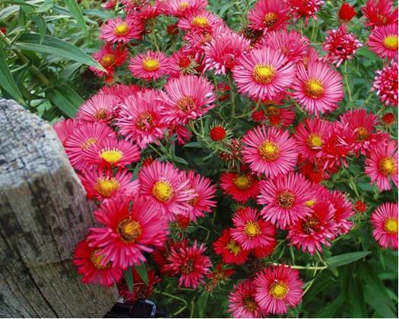
Flower/foliage details: New York asters are generally shorter, with most plants being 2-4 feet tall. Flower colours range from pale pink to purple and the stems are thin and leaves are smooth, plant is more bushy and compact and produces more flowers than the New England Aster.
How and when to grow plants from seeds:
Indoor: Sow indoors roughly 4-6 weeks before the last frost, no deeper than 1/8 inch and cover them well with moist seed starting mix. Keep the seeds at a temperature of 18-21 degrees C., keeping them moist, not soggy and under indirect sunlight and provide seedlings with ample light as soon as they emerge usually 14-20 days. Plant young plants outside after the danger of frost has passed in the spring.
Outdoor: Sow seeds one inch deep in soil, placing them in a sunny spot.
Planting/Spacing: Plant young plants outside after the danger of frost has passed in the spring 4-6 ft apart.
Container gardening: Asters can be grown in containers in well-drained compost.
Height: 3-4 ft
Width: 1-2 ft. Divide every 2 to 3 years in the spring to maintain plant width.
Soil/water/growing conditions/care/fertilizer: Medium moisture, well-drained soils. Moist, rich soils are preferred. Provide good air circulation to avoid foliage diseases such as powdery mildew. Add a thin layer of compost or a portion of balanced fertilizer with a 2–inch layer of mulch around the plants every spring to encourage vigorous growth. Water plants regularly to keep them moist but never soggy, pinch back asters once or twice in the early summer to promote bushier growth and more blooms. Cut asters back in winter after the foliage has died, or leave them through the winter to add some off-season interest to your garden. Divide every 2 to 3 years in the spring to maintain plant’s vigor and flower quality. When there is the first sign of new growth in spring, remove the plants from their containers and repot in fresh compost. This is the time to divide them if they are large enough.
Sun or shade: Thrive in full sun or partial shade.
Bloom period: Late summer to late fall.
Harvesting seeds: Each tiny seed is attached to a tuft of fine, fluffy down that makes them easy to harvest and handle. Snip off the seed heads after the down dries out and turns off-white, then simply pull off the seeds by hand and spread them on a baking sheet to dry out for one or two days.
How to Propagate New York Aster: Asters can be reliably propagated by division. Once a group of asters has grown into a clump large enough to divide, usually every three years or so, use a shovel to cut into the clump, dividing it into two or more parts. Dig up the cut parts and promptly plant them in their new location.
Attracts/repels: Attracts butterflies, moths and bees

Black Eyed Susan or Rudbeckia - small flowers, reddish centre (Limited Supply)
NOTE: Black Eyed Susan is a common name for many different flowers. They all look similar, but Rudbeckia Hirta, Rudbeckia Fulgida, Rudbeckia Triloba, are all quite different!

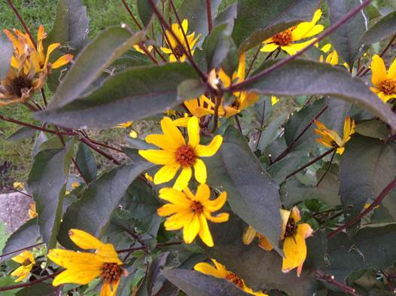

Flower/foliage details: Flower heads range from small flowers with reddish center and purple leaves to large and showy flowers ranging in various shades of yellow at the ends of long, thin, erect branches, 2.5 -7.5 cm (1 -3 in.) in diameter with ray florets (c) orange to orange-yellow and spreading like spokes of a wheel; disk florets (d) dark purple or blackish.
How and when to grow plants from seeds:
Indoor: Sow indoors 6-8 weeks before last frost, or direct sow about 2 weeks before last frost. If starting indoors, provide bright light and maintain a soil temperature of 21-25°C. Expect germination in 5-21 days. Sow seeds on the surface of the soil.
Outdoor: You can directly seed Black Eyed Susan's 2 to 4 weeks before your average last frost. Black Eyed Susans are a fantastic candidate for winter sowing.
Planting/Spacing: About 18” apart
Container gardening: Black Eyed Susans can be grown in containers. They should be grown in pots that are at least 1 gallon (4 L) or larger, and placed in a location that receives 6-8 hours of sun.
Height: 2-6 feet
Width: 2 feet
Soil/water/growing conditions/care/fertilizer: Clay soils hold moisture longer than sandy soils, so expect to water more frequently in sandy settings. These plants are heat and drought tolerant. Plant seeds in moist, well-drained soil. Deadheading encourages more blooms and a sturdier, more compact plant but also prolongs the blooming period, but can also lead to a second bonus blooming period later in the season.
Sun or shade: Black-eyed Susan grow best in full sun (at least 6-8 hours per day). They can tolerate some shade, but you might eventually find them stretching and spreading toward the light.
Bloom period: Late summer to fall (regular deadheading not only prolongs the blooming period, but can also lead to a second bonus blooming period later in the season)
Harvesting seeds: Seeds may be allowed to dry on the stem for reseeding or collected and dried in other ways for replanting in other areas. Seeds of this flower do not necessarily grow to the same height as the parent from which they were collected.
How to Propagate Black Eyed Susan: Black Eyed Susan can be divided in early spring, just as growth begins to develop, or in the fall after they finish flowering. Simply dig up the root ball and cut it with a sharp knife, making sure each division has roots. Replant the divisions about 12 to 18 inches apart.
Attracts/repels: Attracts butterflies, bees, and other pollinating insects. Birds are also attracted to black-eyed Susan seeds include chickadees, Cardinals, White-breasted Nuthatches, and sparrows.
Marigold (Triploid Hybrid variety) (Limited Supply)

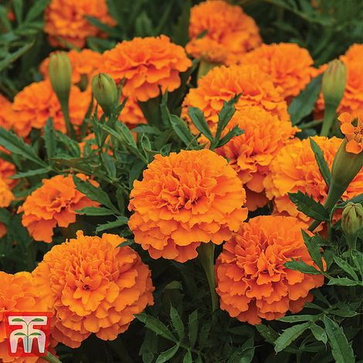
Flower/foliage details: Marigold flowers are available in shades of orange and yellow; some with highlights of red, gold, copper or brass.
How and when to grow plants from seeds:
Indoor: Sow seeds in seed trays to transplant with root system is established. While it is very easy, starting marigolds from seed indoors offers no real advantage because they germinate as quickly outdoors.
Outdoor: Sow seeds directly in the garden 1-inch apart and they sprout about 1-inch apart sprout within days in warm weather and plants bloom in about 8 weeks.
Planting/Spacing: This dwarf variety can be spaced 15cm (6″) apart.
Container gardening: Generally any Marigold is good for pots but don't crowd potted marigold plants, as healthy marigolds require plenty of air circulation. One marigold is enough for a 6-inch (15 cm.)
Height: 3 feet or 6-12 inches.
Width: Annuals.
Soil/water/growing conditions/care/fertilizer: Marigolds prefer fertile soil, preferably loose and loamy with adequate drainage, yet can also tolerate dry conditions. Marigolds are no-fuss annual that can bring the color of sunshine to a garden.
Sun or shade: Full sun, to partial shade. Most marigolds prefer to be located in an area with full sun but will tolerate some shade. During times of extreme heat, some afternoon shade is beneficial.
Bloom period: Late spring until fall.
Harvesting seeds: Plan to harvest the seeds when the petals are dry and the base of each bloom (the seed pod) is turning brown. To harvest, simply remove each marigold flower head from its stem.
How to Propagate: Marigold plants cannot be divided but can be grown from cuttings.
Attracts/repels: They attract butterflies, bees, ladybugs, and other beneficial insects. Marigold repel mosquitos and other garden pests, including squash bugs and tomato worms. Marigolds contain a natural compound used in many insect repellents. The marigolds will help these veggies deter beetles, slugs leaf hoppers, bean beetles and the dreaded horn worms.

Lupin – 2 colors – Limited supply of both colors
Pink Purple
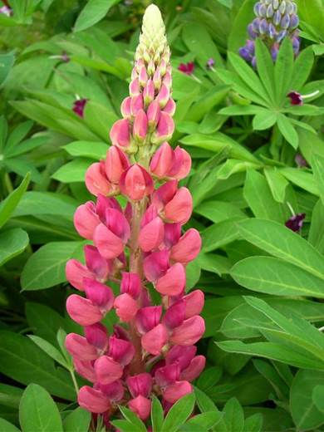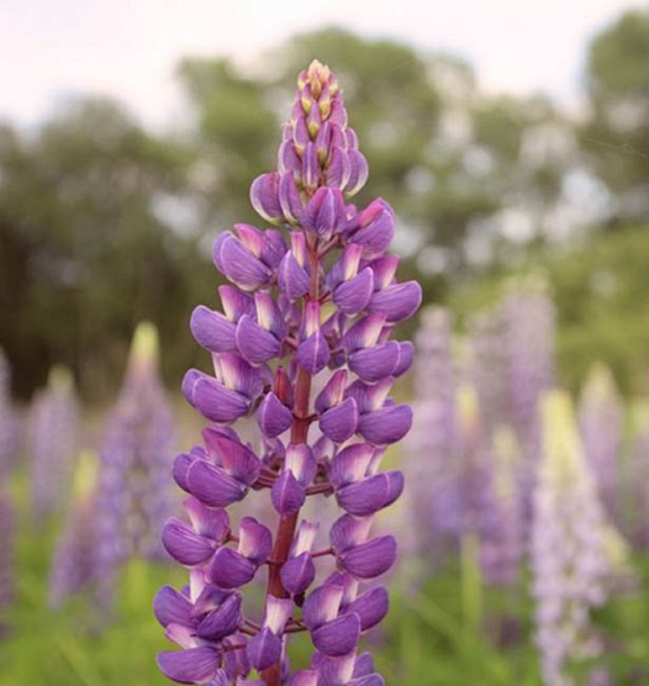
Flower/foliage details: The telltale look is a tall, showy spire of flowers that can come in a multitude of colors. The foliage resembles palm leaves with seven to 10 leaflet segments each.
How and when to grow plants from seeds:
Indoor: If starting indoors, scarify seeds by chipping, or soak in water for 24 hours prior to sowing. Sow 2-3 seeds directly into cell packs (nothing smaller than a 32 tray) or individual containers. Cover seed, as darkness aids germination. They are susceptible to rotting if too damp, and they dislike root disturbance, so transplanting may not be successful. Take 14-28 days to grow from seed.
Outdoor: Lupins work equally well direct sown in early spring when some risk of frost is still possible. Sow seeds in early to mid-spring. The large seeds have a tough coating, so it is best to nick them with a knife, then soak them in water for 24 hours before sowing. They should germinate in 10–14 days at 10–15°C. Lupin seeds will germinate in a wide range of temperatures, the best being about 15°C to 20°C or somewhere around the temperature of a cool room in a centrally heated house. Seedlings should appear in 10 to 15 days time. When they do emerge, keep the plants in a cool, light position. Lupins work equally well direct sown in early spring when some risk of frost is still possible. Lupines usually bloom the first year after planting.
Planting/spacing: Space plants about 2 to 3 feet apart. When planting, loosen the soil deeply to accommodate the long taproots.
Container gardening: Yes, you can grow Lupins in pots. They grow quite large, so you'll need a larger garden pot. ... Make sure your container is filled with well-draining soil and place them in a location where they will receive full sunlight. hey will grow very well in a large container. Put a piece of broken crock over the drainage hole to prevent silt blocking the hole. Fill with good quality loam-based compost mixed with a little horticultural grit to improve the drainage. Plant at the same depth as it is in the pot and water after planting.
Height: Roughly 2 feet (60 inches)
Width: 1 ft.
Soil/water/growing conditions/care/fertilizer: Lupines like well draining acidic or average fertility soil though not heavy clay, extremely chalky, alkaline soil. It is best to plant them on soil that has not been amended with the addition of any composts but organically rich. While lupines don't like soggy soil, which can cause root rot, they prefer regular watering. Water at least weekly if it has not rained to prevent the soil from drying out. Lupines like climates with fairly cool summers. They don't do well in hot, humid climates. High heat and strong sunlight can result in the plants failing to flower. In hot climates, a light layer of mulch around the lupines can help to retain soil moisture and keep the roots cool. Lupines generally don't require fertilizer, and too much fertilizer can encourage excess foliage growth at the expense of blooms.
Sun or shade: Prefer full sun, avoid planting in shade, as flowering will be poor.
Bloom period: Spring, summer.
Harvesting seeds: Allow the seed pods to turn brown then remove them from the plant and open up the pods to get at the seeds. Seeds will be available in July to August time. Store until required in a cool, dry dark place. The seeds will keep for three years or more if stored correctly.
How to Propagate: Since lupines sprout so easily from seed, this is the normal method for growing them. But lupines can also be propagatedap carefully taking basal cuttings from established plants in the spring. Use a sharp knife to sever a segment of crown and roots from the parent plant, and transplant it to a new location. It's important to do this in early spring before the plant has begun to actively grow and leaf out. It's a good idea to propagate your Lupines every two to three years, as they are short-lived plants. Basal propagation ensures that you'll have an ongoing stock of your favorite plants.
Attracts/Repels: Attracts: Bumble bees and butterflies Hummingbirds, butterflies, mason bees, miner bees, carpenter bees.

Note: Perennial lupines grown from seed likely won't bloom until their second year.

Heliopsis helianthoides 'Sunstruck’: Golden yellow flowers above the cream and green variegated foliage (Limited supply)

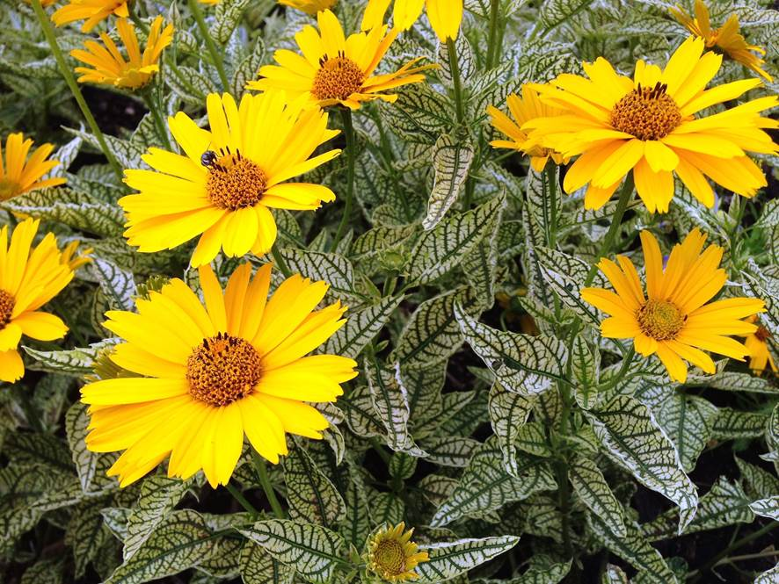
Flower/foliage details: Classic, long lasting, bright golden yellow, daisy-like flowers with sunny gold centers contrast nicely with the shimmery, variegated, toothy foliage - creamy white leaves with dark green veins
How and when to grow plants from seeds:
Indoor: Plant seeds 6 - 8 weeks before the last frost. Use sterile starter mix and gently press the flower seeds into the soil. Pinch back Heliopsis seedlings at time of transplanting to encourage a bushier growth. Sow Heliopsis seed in cell packs or flats, press into soil and cover lightly in one to three weeks and grow quickly from that point, so be sure to plan for supplemental light if started in winter. Allow four to six weeks from germination to transplant the plugs or cells. Plant sunflower seeds at least 1/2 inch deep. Space seeds 6 inches apart. If planting in rows, you'll want 2 to 3 feet between each row. Cover the seeds lightly with germination mix or medium grade vermiculite to help keep the seed moist during germination. Light is beneficial for germination; avoid covering them too deeply. Plants should be thinned out in a few weeks to the proper spacing.
Outdoor: Sunflowers can be sown straight in to the ground where they are going to flower once the ground is nice and warm. so make sure the space you are going to sow is weed free, by using a trowel to remove the weeds. Rake the soil to a fine tilth (a fine crumbly texture) and make some drills 12mm deep.
Planting/Spacing: 18" - 24" (45cm - 60cm)
Container gardening: This variety is well suited for production in small (5-inch) to intermediate-sized (one-gallon) containers. It performs best when it is grown in a good quality, well-drained peat or bark based growing medium.
Height: 2 inch
Width: Grows wider each other and can be divided.
Soil/water/growing conditions/care/fertilizer: Will thrive in most garden soils, tolerates heavy clay, average, dry to medium moisture, well-draining. Transplant every three to four years in the fall after flowering to divide and rejuvenate their growth. Deadhead spent blooms to stimulate new buds. That will keep the floral display going into fall. Deadheading also helps prevent self-sowing. Cut back one to two times—once at transplanting and once again four weeks later to keep more compact.
Sun or shade: Full direct sun up to 6 hours or part shade 4-6 hours.
Bloom time: All summer until early fall.
Harvesting seeds: Leave the flower head on the stem for at least 2 weeks. Once the petals have faded, cut the flower heads off and store them in a sunny, warm, dry place for another week. Spread a sheet of newspaper on a flat surface, gently rub the seed head and the seeds will fall away easily. Heliopsis can be grown from seed, but a better bet is to divide clumps every three to four years in either spring or fall.
How to Propagate: Heliopsis 'Sunburst' is easily propagated by seed or divide clumps every three to four years in either spring or fall.
Attracts/Repels: This species is pest resistant and unpalatable to deer and other herbivores. raspy leaved and resistant to rabbits.

Pink Sizzle Poppy (Feathery poppies): Short, pink

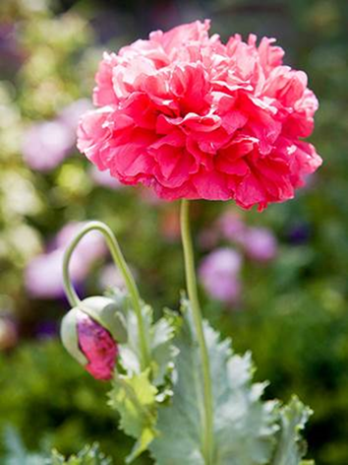

Flower/foliage details: Sparkling shell-pink flowers with striking pure white centers. Flower petals are fringed, with lacy edges. Attractive lettuce-leaf type foliage is silver-green. Green-blue seed pods follow bloom.
How and when to grow plants from seeds:
Indoor: Poppies are famously difficult to transplant, so starting them indoors is not recommended. If absolutely necessary, use peat or coir pots, and maintain a soil temperature of 12°C. Seeds will sprout in 20-30 days. Poppies have very sensitive root systems and do not transplant well at all. With care, they can be sown indoors and transplanted while young, but often better results are gained when seeds are simply sprinkled outdoors where they are to grow.
Outdoor: Choose a sunny spot with good drainage. Weed the area and rake to a fine tilth. Pour some poppy seeds into your hand and sprinkle them very thinly across the ground to create natural looking drifts. Allow 7-30 days to germinate, depending on the variety, soil condition and growing temperatures. Sow poppy seeds directly into your garden in spring or autumn. Pour some poppy seeds into your hand and sprinkle them very thinly across the ground to create natural looking drifts. Allow 7-30 days to germinate, depending on the variety, soil condition and growing temperatures. Keep the soil moist during germination. Once the seedlings are large enough to handle, thin them out to around 30cm (12in) apart. Water the area regularly, especially during dry spells. Be careful not to overdo it as this encourages quick growth and leggy plants, or even rot. If you’re planting early in the year, usually in May is best, but you’ll have to wait until the following summer for a healthy display. Sow from the end of April through May, or sow in late August to September. Be ruthless, just leave the biggest and most healthy looking. By doing this, you’ll get more flowers and pods per plant that are bigger and stronger.
Poppies are best when they are grown from seed that is planted in fall or winter, even in cold winter areas. The seeds need to go through the natural freeze and thaw cycles to germinate and that is accomplished by fall sowing. They can also be sown in early spring, about a month before your last frost date. Sow in spring, early summer or autumn, where they're to flower. Prepare the soil by removing weeds and rake the ground level. Water the soil with a fine spray of water and then scatter the seed. There's no need to cover it. It takes eight weeks for the poppy plant to grow about one to two feet.
Planting/spacing: 30cm (6-12in) apart by early summer
Container gardening: It is not difficult to grow poppies in containers as long as you plant them in the correct sized pot, use quality soil, and give them adequate light and water. ... These plants like humus-rich, loamy soil. You can create a favorable soil blend for poppy flowers in a pot by amending regular potting soil with some compost.
Height: 60-90 cm (24-36 in)
Width: N/A (will grow more by self-seeding plants to prevent self seeding remove the flower heads early before they set seed.
Soil/water/growing conditions/care/fertilizer: Poppies will grow in most soils but for the best results grow in a well-drained soil in full sun. They thrive in alkaline, acid or neutral soil. The larger, perennial oriental poppies are perfect for growing in a border, ideally at the front or middle. Once established, poppies generally do not need any extra watering unless in a long dry spell. Apply any water at the ground level and avoid wetting leaves, which promotes fungal diseases. Deadhead faded poppy flowers often to encourage more blooms. If left to seed poppies self-sow, so avoid unwanted spread by removing faded flowers in good time. Poppies don’t need to be watered too often, but when you do water, give the plants a deep soaking. This will promote strong root growth. Poppies love to self seed and will add a splash of colour to the borders. The most serious problem for these poppies is root rot. Excellent drainage is a must. Once they get established the plants are very hardy. You can deadhead peony poppies to get rebloom. Follow the stem of the spent bloom down to the first set of leaves and cut the stem just above those leaves. In many cases you can see the incipient flower bud forming where the leaf attaches to the stem.
Sun or shade: Full sun.
Bloom period: July-September.
Harvesting seeds: To harvest seed pods, cut when the pods turn light brown and dry out for 1-2 weeks before breaking open and storing seeds in a jar for up to two years. Once annual poppies have gone to seed, pull up parent plants and compost. For biennials and perennials, cut back old foliage to ground level in autumn.
How to Propagate: Cut the root into 4cm lengths and push them vertically into a pot of cutting compost with the thickest end at the top. Cover the pot with a thin layer of grit, and water. Leave the pots in a cold frame and wait for little plants to form before potting on.
Attracts/Repels: Attracts a variety of bees, particularly bumble bees, honey bees and sweat bees, and is mainly pollinated by beetles. Butterflies are also attracted to the poppy nectar. After the flowers are gone birds are attracted to the seeds.

Sweet Peas (Lathyrus odoratus) - purple, white, pink mix (Limited Supply)
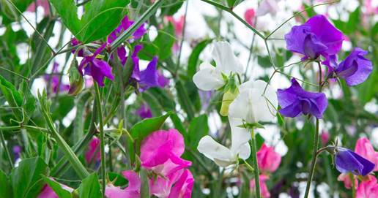
Flower/foliage details: Sweet peas are climbing plants that bear clusters of flowers in a wide variety of colors, including red, pink, blue, white, and lavender. They are spring and early summer flowers with beautiful blooms and make excellent cut flowers. The flowers resemble fringed butterflies, while their stems appear to be folded.
How and when to grow plants from seeds:
Indoor: You can help activate germination by nicking the seed coat with a knife, avoiding the 'eye' area or soak them in warm water for 24 hours. Maintain a soil temperature of 12-18°C. Seeds should germinate in 10-16 days. In May, once your sweet peas are growing well and the main risk of frost has passed, you can pop them outside to acclimatise them to outdoor conditions for a week or so before planting them in their final position.
Outdoor: Do not plant sweet peas out too late or they will not have much time to flower. It's recommended you plant your sweet peas before the end of May.
Planting/Spacing: About 20cm apart
Container gardening: Sweet Peas can be very successfully grown in containers providing the container size at least 6 in (15 cm) deep and 8 in (20 cm) in diameter thus has sufficient volume for the number of plants with a minimum size of 20 litres. Sweet Peas have a large root system and can easily become pot bound. Plant your peas 2 in (5 cm) apart. Dwarf variety can be grown in hanging baskets.
Height: Sweet Peas grows as a vine they need support to grow up and flower. Many types of structures can work such as a trellis, supports with mesh or twine, or fences. They need a structure that is well anchored in the ground to support the weight of the vines and should be installed at the time of the planting.
Width: Sweet Peas are climbers and you'll need to provide a suitable support as sweet peas are climbers. Put your support frame into position before you start planting.
Soil/water/growing conditions/care/fertilizer: Build up the soil in the area where you intend to plant with compost and well-rotted cow manure. Soil should be rich, deep, loamy, moist, and well drained. Sweet Peas grow best in slightly alkaline soil with a pH of 7.0–7.5. In order to raise the alkalinity of your soil, you can apply lime or dolomite to your soil. Use well-rotted manure or compost at planting. Sweet peas are heavy feeders, so amend soil well before planting with lots of rich compost or well-rotted manure. During the growing season, fertilize at least twice with a good soil drench of tablespoon each of fish emulsion and liquid kelp per gallon of water. Most varieties have tendrils that will 'self-cling' to supports, but some sweet peas will need tying in. Keep the plants well watered. Feed your sweet pea plants with a general fertiliser every couple of weeks, or sprinkle on comfrey pellets. A potash-rich tomato feed is ideal. If you maintain a good watering and feeding regime, the sweet peas can go on into August.
Sun or shade: They need a good source of light. Indoors you can place them by a window as long as they will not experience extreme heat from the sun during the day. Cooler night temperatures by a window are not a problem for sweet peas. You can also use fluorescent lights. For best results, peas need at least six to eight hours of full sun exposure daily. Pea plants will tolerate partial shade (especially in the hottest part of the day), but they will grow slower. Make sure you plant the sweet peas outside after the last frost date in your area. Choose a spot in full sun or very light dappled shade with rich, well-drained soil.
Bloom period: Late spring to summer though the timing of bloom will depend on whether the plants have been pinched back. Pinching may slow growth somewhat, but it will produce bushy plants with more flowers.
Harvesting seeds: Bring the seedpods indoors and remove the seeds from the pods. Line a flat surface, such as a countertop or cookie sheet, with newspaper and let the seeds dry for about three days. Once dry, put them in a freezer bag or Mason jar with a tight-fitting lid to keep them dry.
How to Propagate: Make Your Cuttings. Using a sharp pair of clean scissors, cut a 5 inch piece of stem just above a pair of leaves. Place cuttings in water and wait for roots to develop before planting it in soil.
Attracts/Repels: Hummingbirds, bees, butterflies and birds are attracted to Sweet Pea.

Mixed wild flowers
Mix includes the following flowers: Calendula Officinalis, Centaurea Cyanus, Cheiranthus Allionii, Cheirsnthus Cheiri, Chrysanthemum Maxmum, Coreopsis Tinctoria, Cosmos Bipinnatus, Cynoglossum Amabile, Delphinium Consolida, Dianthus Barbatus, Digitalis Purpurea, Eschscholzia Californica, Gypsophila Elegans, Linum Grandiflorum Rubrum, Linum Perenee, Lupinus Perennis, Malope Trifida, Papaver Rhoeas, Rudbeckia Hirta.
Flower/foliage details: A wide range of colors, wide range of flower height, shapes and foliage.
How and when to grow plants from seeds:
Indoor: Wildflowers can be grown from seed indoors. ... Wildflowers usually are very showy, and flower lovers everywhere have been known to gather seeds to be planted in home gardens. Wildflowers are easy to care for and will grow in an indoor environment if they are given the proper amount of light and care. Depending on the type of carton you have, you can even cut apart the individual sections and plant them, as the carton will biodegrade. Be sure to poke small holes for drainage, and put the cartons on a tray or in a shallow pan to catch any residual water. The seeds should start sprouting in about two days, though older seeds can take up to a week to sprout. You can remove them from the water and place them in the soil at any point once they've sprouted
Outdoor: Dig over the soil with a ford or spade and break up la, rake it to a fine tilth and sprinkle wild flower seeds on top. No need to cover the seed. These beauties need light to stimulate germination. Use a watering can with a rose to moisten the soil and then keep it damp until the baby plants are growing strongly. Dig over the soil with a fork or spade and break up or put aside large clumps. Remove weeds so the wildflowers don't have any competition, and any large stones. Rake the soil so it's fine and crumbly - lumpy soil may bury seeds; if it's too hard, roots will be unable to penetrate the ground.
Planting/Spacing: N/A
Container gardening: Any container that will hold soil will do fine for wildflowers. Make sure that the container is clean and dry before you begin. If there are no drainage holes in the bottom of the container, make several holes to allow the water to drain. Many wildflowers have tremendously deep roots that can grow down 10 feet or more into the soil, well below the grasses root systems. The grasses and flowers thus share the soil rooting environment and utilize water and nutrients extremely efficiently.
It is recommended that you only soak most seeds for 12 to 24 hours and no more than 48 hours. ... After soaking your seeds, they can be planted as directed. The benefit of soaking seeds before planting is that your germination time will be reduced, which means you can have happy, growing plants faster. tuck seeds directly into soil outdoors. Planting seeds this way is called direct sowing, and it is an easy process that yields great results.
Height: 1 to 2 ft
Width: N/A
Soil/water/growing conditions/care/fertilizer: Compress seeds into the soil as this encourages good seed to soil contact. Gently water for proper germination so that the soil is moist, not soaking wet. For a week water daily and then semi-weekly.
Sun or shade: Wildflower meadows are often associated with open, sunny swathes of land, but there are plenty of gorgeous wildflowers to grow in shade. Even the smallest spots can be used to grow wildflowers – try creating a mini wildflower meadow, or take a look at more ways to create a mini meadow.
Bloom period: May to July.
Harvesting seeds: There are several methods for collecting the seeds once they have matured. For wildflowers with dried seed pods and heads, the easiest way is to cut the pod or head off the plant with a pair of scissors. ... This should release the seeds from their pods and heads and leave you with a bag full of usable seed.
How to Propagate: If the flowers have already gone to seed or still have dried seeds on them, it is perfectly safe to cut them back to the ground. After you cut off the tops, shake out remaining attached seeds into areas you'd like them to come up in next year.
Attracts/Repels: Wild flowers attract all kinds of beneficial insects – not just bees and butterflies, especially Monarch Butterflies but also predatory insects such as hoverflies, ladybugs and other wildlife. They keep common pests like aphids under control. natives will not only attract bees and butterflies, but also other pollinators and wildlife.

Silence/Lynchis Coronaria – Rose Campion variety (Limited Supply) - Magenta

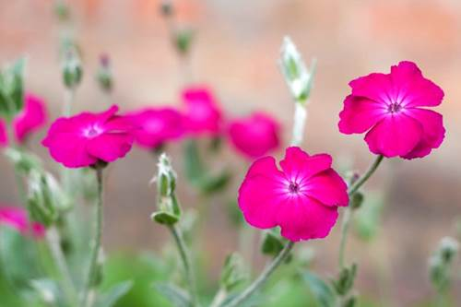
Flower/foliage details: Ornamental flower with bright magenta blooms and silvery, woolly gray foliage.
How and when to grow plants from seeds:
Indoor: Place in a propagator or warm place, ideally at 20 to 24°C. Keep the compost moist but not wet at all times. Germination takes 17-21 days. Start rose champion seeds indoors approximately 8 to 10 weeks before the last spring frost. Place the seeds inside a plastic bag filled with moistened sphagnum moss and store them in the refrigerator for three weeks to break their dormancy. Re-moisten the sphagnum, as needed. Sow the rose champion seeds in individual 3-inch starter pots filled with moistened seed-starting compost once the chilling period has ended. Sow two in each pot. Press the seeds firmly onto the surface of the compost to anchor them. Do not cover them with soil since light aids their germination. Place the starter pots on a nursery tray. Set the tray near a south-facing window with at least six hours of sunlight each day. Cover the pots with a propagation dome or a sheet of clear plastic wrap to hold warmth and moisture near the seeds. Spritz With a Spray Bottle Water the rose champion seeds whenever the compost feels barely moist on the surface. Water with a spray bottle to avoid displacing the seeds. Do not allow the surface of the compost to dry out completely. Watch for Sprouts. Thin the rose champion seedlings to one per pot. Grow them under bright conditions indoors with a 1/2 inch of water weekly until after the last spring frost.
Outdoor: Planting the seeds in early fall is highly recommended, as is sowing the seeds close together if you want a massed effect. The seeds need about three weeks of moist cold for good germination. If started indoors in spring, seeds require light and three weeks of moist chilling. Mist the bed heavily to help settle the rose champion seeds onto the soil. Use a garden hose with a misting nozzle rather than a shower-type nozzle to help keep the seeds from washing away. In the spring when the soil reaches 21⁰C, germination will occur within about 3 weeks. You can thin your seedlings to 12 to 15 inches apart.
Planting/Spacing: 2 cm. Move the rose champion seedlings to a bright, sheltered area outdoors after the last frost. Acclimate them to direct sun and normal outdoor conditions for one week before transplanting them 1 to 2 feet apart in a sunny bed with poor, fast-draining soil.
Container gardening: Campions are perennial flowers commonly grown in flower beds but can be grown in pots.
Height: 6-12 in (1-3 ft)
Width: Spreads through re-seeding
Soil/water/growing conditions/care/fertilizer: Fairly dry, well-drained conditions are preferable but will tolerate clay and moist soil. Once the flowering season is over in the fall cut back to ground level. It may be necessary to mulch these plants in cold areas like Ottawa for protection in the winter. Flowers will appear in the second year. Flowers are sparse the first year but numerous in the second year. In the third year, the numbers of blossoms begin to decline, but they are eager reseeders that regenerate themselves every year Seedings also grow next to the base of other plants, even in gravel so it doesn't take much soil for the seeds to germinate but if you do not want that, you can harvest seeds to grow them in an area of your choice. If the seeds drop and germinate you will have little seedlings coming up everywhere the wind blows them. If you want to encourage self-seeding, don’t mulch around the plants. The first year, the rosette of leaves will form.
Sun or shade: As with many silver-foliaged plants, rose campion prefers in full sun or partial shade
Bloom period: Has a long season of bloom as it withstands hot, dry summers. This perennial is shunned by deer and other four-legged nibblers.
Harvesting seeds: Let the seed pods dry, shrivel and turn real dark and the seeds are ready to be harvested. The pod will have an opening on top or you can cut off the pod and turn the pod down and very small black seeds will fall out.
How to Propagate: Leave the ground undisturbed around dead plants and seedlings will appear in spring. If you let self-seed, you can move the little seedlings where you like them to grow.
Attracts/Repels: Attracts, Butterflies, Hummingbirds, deer resistance.

‘American Giant’ Helianthus Annuus – Sunflower (Limited Supply)
(Below is my friend who shared her seeds with me to sell for United Way)

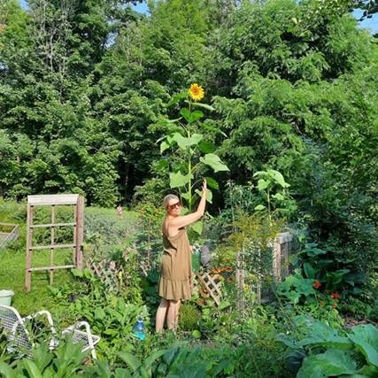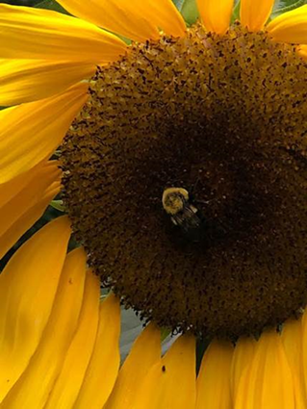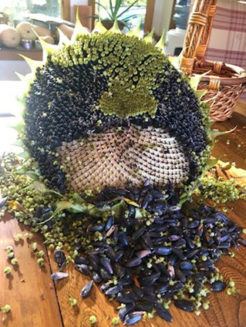
Flower/foliage details: American Giant sunflower is vigorous, erect annual with oval to heart-shaped, roughly hairy, toothed, mid- to dark green coarse leaves and stout, sturdy stems bearing huge, bright yellow single daisy-like flower heads.
How and when to grow plants from seeds:
Indoor: Sunflowers take from 70 to 90 days to mature with the larger flowered varieties taking the longest, so you'll probably want to get a jump on the season by planting sunflowers indoors about three weeks before the last frost date. in individual 10cm pots of moist seed compost in April to May, cover with cling film and place on a sunny windowsill or greenhouse bench. Remove the cling film once the seeds have germinated, and water plants regularly, allowing the water to drain. Pot on into larger pots with multipurpose compost, before eventually planting outside once all risk of frost has passed. Keep the soil moist but not wet.
Outdoor: Once the frosts have passed it is time to plant sunflowers into the garden. If planting straight into the soil, look for a sunny position with shelter from winds. A position against a wall is usually best. Try to avoid sandy soil and rich-free draining soil will be most successful. Plant the seeds about 30cm apart and about 3cm below the surface. Sunflowers do like a lot of water so to get the best out of your plant try to water it every day, but keep and eye on the soil and roots as constantly damp and soggy roots will make the plant unstable and could lead to root rot.
Planting/Spacing: 20-24 inches apart.
Container gardening: Potted sunflowers may seem an unlikely endeavor, however, some of the smaller dwarf varieties do very well as container grown sunflowers, and even the giant cultivars can be grown as container plants. Growing sunflowers in a pot or planter does require some special care though. Giant sunflowers can be grown indoors if you have enough space and light. Sunflowers also withstand wet, humid weather, although well-draining soil or containers are essential in such climates. if you want your sunflower to grow really tall, it's best to plant it in the ground
Height: Can grow 5-13 feet tall (me (5 feet) up to double of me, OMG!
Width: N/A
Soil/water/growing conditions/care/fertilizer: Sunflowers prefer a somewhat alkaline soil (pH 6.0 to 7.5) and they're heavy feeders so make sure you plant them in nutrient-rich soil. You should also make sure your soil is weed-free before you do any planting! They prefer loose, fertile soil for healthy growth, but are tolerant of a range of soil types. For planting sunflowers in high-clay soil with slow drainage, soil amendments are recommended. It is not recommended to plant sunflowers in sandy soil as they need a strong base to support their tall, top-heavy plants. Water regularly. Work in a slow release granular fertilizer – one that also contains trace minerals. Apply a low-nitrogen fertilizer 6 inches away from the plant stems in early summer when new growth begins. Water after fertilizing, so the nutrients can seep into the soil but do not over fertilize as overfertilization can cause stems to break in the fall. While the plant is small, water around the root zone, about 3 to 4 inches from the plant. Once the plant is established, water deeply though infrequently to encourage deep rooting.
Sun or shade: Full sun.
Bloom period: Summer into autumn.
Harvesting seeds: Cut the seed heads leaving 12 inches of stem attached. Hang in an airy place safe from birds and rodents. Heads should be dry in 2-3 weeks. Remove seeds by rubbing two heads together.
How to Propagate: A 4- to 6-inch-long stem with mature leaves and no buds or flowers will root best and produce a shapelier plant. Sever the cutting where it attaches to the main stem using very sharp scissors or a utility knife, and then cut off the lowest set of leaves to expose the root-producing nodes. You can always divide the mother plant in the fall.
Attracts/Repels: Sun flower repels asparagus beetles, leafhoppers, a range of aphids, tomato worms. You can use sunflower s a way to draw aphids away from my other plants. Ants move their colonies onto sunflowers. The sunflowers are tough enough that they suffer no damage. Sunflower attracts bugs and beetles, Cutworms, ladybugs, spiders, bees, snails, butterflies, moths, aphids, seed Weevils, squirrels, rabbits, birds, deer, mice, rats, hedgehogs, chipmunks, Raccoons. Sunflowers are favored for crop rotations because they help in long-term management of weeds and diseases, the plants add biomass to the soil after harvest.

Note: Helianthus 'American Giant' is known for attracting bees, beneficial insects, birds, butterflies​/​moths and other pollinators. It nectar-pollen-rich-flowers and has seeds for birds. deer do love to eat sunflowers.

4 O Clock (Mirabilis Jalapa) – 2 colors mixed (Limited Supply)

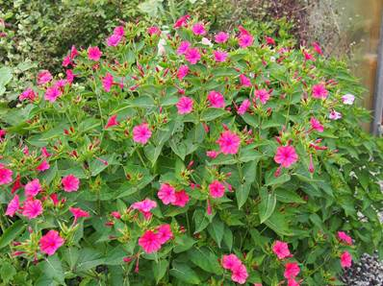
Fuchsia
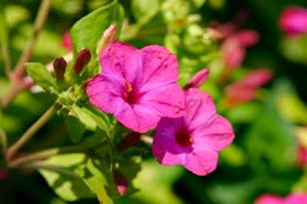
Red
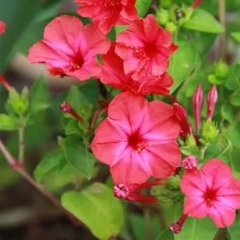

Flower/foliage details: The shrub-like, erect and spreading, tubular-shaped blooms have a lemony-sweet fragrance and come in colors of white, pink, purple, red and yellow. Bi-color flowers are common, such as a white flower with red markings on the throat. The foliage is light or bright green but may have a yellow or pink hue. The opposite, ovate, bright green leaves are up to 4 inches long with a pointed end. These tuberous-rooted plants produce slightly pointed oval leaves on branching stems. They get their common name because of the way they bloom. The flowers open in the late afternoon, typically around 4 p.m. or so, and then remain open until the next morning. The approximately 2-inch-long blooms are trumpet-shaped with five petals, and they come in several colors, often shades Fuchsia and Red of. Some four o’clock plants produce flowers in multiple colors, sometimes with marbling or other markings. This is a fast-growing plant that often sprawls in the garden.
How and when to grow plants from seeds:
Indoor: Start four o'clock seeds indoors four to six weeks before the last spring frost if you're in an inland area with late-season frost. Fill a 3-inch starter pot with sterile potting mix for each four o'clock plant you wish to grow. Sow indoors 6-8 weeks before frost in spring using a seed starting kit. Sow evenly and thinly and cover with ½ inch of seed starting formula. Firm lightly and keep evenly moist. Seedlings emerge in 7-10 days. Soak seeds overnight in warm water the night before planting to hasten germination.
Outdoor: It’s best planted in the spring. These plants can be sown directly in the garden in the spring once the danger of frost has passed. For best germination, soak the seeds overnight in water. Then, plant the seeds about 1/4 inch deep in your garden soil. You also can start seeds indoors roughly six to eight weeks prior to your area's projected last frost date. Plant them in a seed-starting mix about 1/4 inch deep, and place them by a light source. Keep the soil moist but not soggy as you wait for seedlings to appear. Soak seeds overnight in warm water the night before planting to hasten germination.
Planting/Spacing: 2 feet apart
Container gardening: The plants may grow to around 90cm (3ft) in height and spread to around 60cm (2ft) when grown in the border but are usually much smaller if grown in containers. You can also grow four o clocks in 1 to 5 gallon-sized pots growing 2 to 5 plants per pot depending on the pot size. Keep the containers well watered and fertilized monthly. Keep plants well watered and weeded. Plants grown in containers will generally need more regular watering than those in the ground.
Height: 2-3 ft
Width: 2-3 ft
Soil/water/growing conditions: Prefer to be sited in moderately fertile, moist but well-drained soil. These plants can grow in a variety of soil types. But rich, loamy, well-drained soil is ideal. And a neutral to slightly acidic soil PH is best. Do not let these plants dry out; water whenever the top 1 to 2 inches of soil becomes dry. But avoid overwatering, as soggy soil can cause root rot. Mulching around the plants can help to keep the soil sufficiently moist. In dry weather, when the plants can get a little ragged looking, a shearing back by about a third will refresh them. No pruning is really required, but if you remove wilted flowers when they appear, this will enhance production of new flowers. Even though it tends to become invasive because four o'clock flower re-sows itself year after year, it is still quite easy to control its growth by pulling out excess plants when they sprout. Fertilize in mid summer with an organic plant food to spur more growth and flowering. Expect to water your plants fairly regularly if you don’t have rainfall, and feed them throughout the growing season. They’ll also need a bit of pruning to keep them looking fresh and healthy. Four o’clock plants thrive in warm temperatures and are often grown as annuals in cooler climates outside of their growing zones, where the plants die once frost and cold fall temperatures arrive. Humidity typically isn’t an issue for them as long as adequate soil moisture is maintained. Apply a balanced fertilizer in the spring, and continue to feed monthly until fall. However, if you already have rich soil, you might only need to give your plants the one spring feeding. Because four o’clock bloom so profusely, keeping them deadhead (removing spent blooms) is all but impossible, which is fine because they don’t really need it to keep blooming.
Sun or shade: Prefer full sun, meaning approximately six hours of direct sunlight on most days although they will tolerate partial shade. Providing sufficient light is typically the best way to get the most blooms out of your plant year after year.
Bloom period: Summer through fall
Harvesting seeds: The seeds are difficult to find once they fall to the ground, so it's best to pick them just as they turn dark brown and dry out. One way to ensure a good seed harvest is to cover the flower heads with nylon pantyhose, which will catch the seeds as they drop without restricting air flow. Furthermore, chances are good that if you allow your plants to go to seed in the fall, they will self-seed in the garden, especially in warmer zones. Seedlings can be easily uprooted and moved to another location if you wish.
How to Propagate: After the plant is done blooming in the fall, the tuberous roots can be dug up and stored for winter in a cool (but not freezing), dark location. Replant them the following spring once temperatures are reliably above freezing. If you live within the plant's growing zones, the tubers can stay in the ground for winter.
Attracts/Repels: Four o’clock tend to be very pest- and disease-resistant, will attract hummingbirds and nocturnal pollinators to your garden.

NOTE: All parts of four o'clock plants are toxic both to people and pets

Cosmos – Mix of white, purple and pink flowers with yellow center

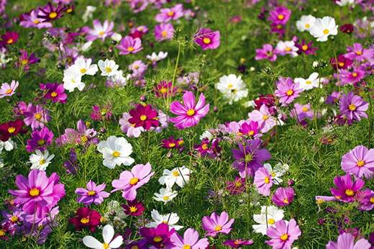

Flower/foliage details: Cosmos comes in white, light purple, pink, their flowerheads may be bowl– or open cup–shaped and the leaves are finely cut into threadlike segments.
How and when to grow plants from seeds:
Indoor: started indoors in late winter for transplanting after last frost, once daytime temperatures are above 10°C (50°F). Seeds will sprout in 3-10 days. Optimal temperature for germination: 21-25°C (70-75°F). Sow seeds very shallowly only a few millimetres (1/8″) deep. Seeds can be started indoors to get a jump-start on the season or sown directly into garden beds once the weather warms. Either way, cosmos will bloom in just under 3 months from the date you sow them. It is recommended that you only soak most seeds for 12 to 24 hours and no more than 48 hours. ... After soaking your seeds, they can be planted as directed. The benefit of soaking seeds before planting is that your germination time will be reduced, which means you can have happy, growing plants faster.
Outdoor: Sow cosmos in early spring so the plants can become established before hot weather comes. Cosmos also can be started indoors in containers and set out when the seedlings have at least five leaves, or purchased as bedding plants. Plant seeds in prepared soil about 2 inches (5 cm) apart and one-half inch (1 cm) deep. Prepare the garden with loose, weed-free soil. Sow seeds very shallowly only a few millimetres (1/8″) deep. Thin or transplant to 20-25cm (8-10″) apart. Cosmos plants can be planted out in the garden when all the danger of frost has passed. This is usually around May. Another option is to tuck seeds directly into soil outdoors. Planting seeds this way is called direct sowing, and it is an easy process that yields great results. ... Even so, many vegetables, annuals, herbs and perennials sprout easily from seed sown directly into garden soil.
Planting/Spacing: Space plants approximately 2 feet apart; with tall cosmos, space plants closer than the recommended 2 feet and let them support each other. This will help them to retain water. They should be planted 30 to 45 cm (12-15 inches) away from each other to allow for bushy growth. Plant the seed about one inch deep in your growing medium, cover lightly, and allow for about a week for the seed to emerge from the soil.
Container gardening: can be successfully grown in containers. so look for dwarf or compact cultivars for containers.
Height: can grow anywhere between 18 to 60 inches tall this variety 3-4 ft.
Width: 1-3 ft
Soil/water/growing conditions/care/fertilizer: Cosmos prefer dry, arid soil over wet conditions. Deadheading regularly will help Cosmos to bloom longer. A good tip for deadheading Cosmos is not to just take the flower head off, but cut the stem right back to the first leaf below the flower head. If you pick them just as the buds are about to bloom, they will last 7 to 10 days. Low Maintenance Attracts Birds Good for Containers Cut Flowers. Once in the ground, cosmos will grow rapidly, so be sure to stake them early, while they are still young. Cosmos also benefit from a technique called pinching, as this will encourage them to form a bushier growth habit and produce more flowering. While you don't have to deadhead, doing so keeps the plant looking tidy and encourages a quick rebloom.
Sun or shade: Cosmos prefer full sun conditions, except in extreme heat where they can tolerate part shade.
Bloom period: Early summer and continues until frost if you deadhead.
Harvesting seeds: Once the flowers begin to die back, the cosmos seed harvest can begin. Test a stem on one of your marked blooms by bending it, once the flower dies and the petals begin to fall off. ... Remove all the dried flower heads and place them into a paper bag to capture loose seeds. Cosmos (Cosmos spp.) is a moderate re-seeder, which means that it drops plenty of seeds to bring it back year after year without becoming an uncontrollable nuisance. For cosmos to reseed itself, you have to leave the faded flowers in place long enough for seeds to form. Ideally, harvesting seed takes place after the morning dew has evaporated or in a window of time without rain. It is ideal for flower seeds to be as dry as possible when harvesting, because dry seed helps to avoid early sprouting, eases the threshing and winnowing process, and makes for a better storing product over time.
How to Propagate: First find a healthy Cosmo plant and look for some side shoots on the main plant. Look for a shoot that has 3 to 5 leaf nodes on the stem, and cut under the last leaf node. Keep your cuttings fresh in water while you work. ... Place your cutting into the hole and carefully push soil towards the stem to bury it.
Attracts/Repels: They are a favorite of honey bees, natives alike and attract butterflies and other beneficial insects. Their open flowers provide easy access to nectar and pollen. They repel corn earworm and you can also make a repellent using natural ingredients.

Bee Balm (Wild Bergamot): 2 colors – Fuschia and Red
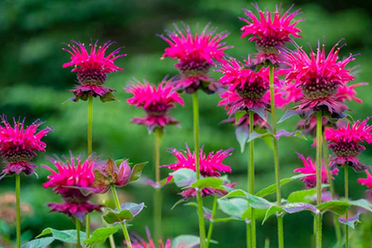
Red Monarda

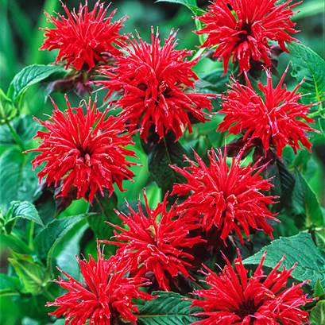
Flower/foliage details: Flowers have an open, daisy-like shape, with tubular petals in vivid shades of fuchsia, red, pink, purple and white. Bee Balm has a minty fragrance
How and when to grow plants from seeds:
Indoor: Sow the seeds eight to 10 weeks before the last expected frost. Put the tray of pots in a plastic bag and seal it. Set the tray in a location out of direct sunlight with temperatures between 60 and 70 degrees Fahrenheit until the seeds germinate. Germination takes roughly 14-28 days. Plant them outdoors 12-18" apart. Seed starting indoors: Start bee balm seeds indoors 8 weeks before the last spring frost. Start seeds in flats or pots under fluorescent lights. Keep the seed starting mix at 55°F or thereabouts. Transplanting to the garden: Transplant well-rooted bee balm plants to the garden one week before the last spring frost. If time permits, seeds are best stratified (placed in the refrigerator) for three months before sowing.
Outdoor: Sow from early spring up until 8 weeks before the first frost in the fall. Direct seed or sow in a cold frame to be transplanted when they reach a height of 3-4" . Sow seeds in the ground in mid-fall after the hot, dry, windy weather abates. Plants sown in fall will put up some green leaves before dying in winter. ... Sow seeds immediately after the last frost. Spring is also a good time to transplant bee balm divisions.
Planting/Spacing: One seed per inch in rows 18-24 inches apart and 1/8 inch deep.
Container gardening: When placed in an area that gets full sun, bee balm can successfully be grown in a container by itself, or as a centerpiece in a larger tub arrangement.
Height: 2-4 ft
Width: Bee balms will self seed and also spread by underground rhizomes and if you do not want that, you can remove the new growth and transplant it.
Soil/water/growing conditions/care/fertilizer: Keep the soil surrounding bee balm moist but not soggy. They also prefer moist, well-drained soils. Bee balm will tolerate drought, but does best if you keep the soil moist, but not soggy. Water when the top one to two inches of soil has dried out. Bee balms like an even supply of moisture during the growing season. For best performance, water bee balms every 7 to 10 days during dry periods. When watering, soak the soil to a depth of 6 to 8 inches. To encourage bountiful clusters of flowers, you will want to deadhead the plant throughout its entire bloom time. As the flowers begin to wilt and fade, cut just above the next flower bud. Cut it back hard and it will come back strong. Also responds to deadheading.
Sun or shade: Full sun to partial shade but will do best in full sun.
Bloom period: Summer to early fall.
Harvesting seeds: It will easily self-sow and also spreads by underground rhizomes. Remove seed heads after all petals have fallen and the seed heads look dry and brown. Dry the seed heads in a paper bag or container. Shak the seed heads around in a sealed container, or paper bag. Sift the seed/chaff mixture using a fine mesh kitchen strainer.
How to Propagate: Propagating bee balm plants is a great way to keep them in the garden year after year or to share them with others. They can be propagated by division in spring or fall, by softwood cuttings in late spring, or seeds. Bee balm propagates by rhizomes, or runners, that spread under the ground to produce new shoots. As these shoots multiply, the mother plant in the center will eventually die off over the course of a couple years. This means your bee balm will eventually be far from where you planted it.
Attracts/Repels: Bee balm has many medicinal and culinary uses – it repels mosquito not only when crushed but while alive. It attracts hummingbirds, butterflies, predatory and bees, you can use them for tea or tisanes and the seed heads will attract birds in the fall and winter. The bright red color of the flowers and the sweet nectar they contain attract hummingbirds, butterflies and bees, hornets, predatory wasps in droves, Bee balm repels deer with its minty scent, rabbits don’t like. Early in the year, slugs can eat the entire new plant, leaving nothing behind. Bee balm is a good plant to choose if you want to attract wildlife to your garden.

