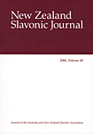 | The Turning Point: Revitalizing the Soviet Economy by Nikolai Shmelev; Vladimir Popov; Michele A. Berdy; I.B. Tauris  Review by A.C. Wilson  New Zealand Slavonic Journal (1992), pp. 234-236
